Fantastic, Mythical, and Legendary Beasts of the Hispanic World
Edited by
Ailén Cruz (Australian National University)
Lauren Beck (Mount Allison University)

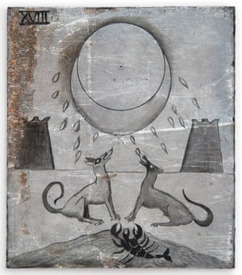
Leonora Carrington “La luna”

Whether unicorns, chimera, giant snakes and troglodytes, or axolotl, jaguars, and phoenix, animals often have the human experience grafted onto them, and reflect society’s values, ambitions, and inequalities. This volume seeks to explore different representations of animals and imaginary beasts across Hispanic literary production and media so to gain better understanding of how they serve as projections of human experience, knowledge, values, and vices. Animals, as well as fantastic, mythical, and imaginary beasts in their various representations make their appearance in codices, explorers’ diaries, manuscripts, novels, artwork, theatre, and film, often in ways that give voice to lessons and stories that influence our worldview. In light of the current climate crisis and social issues stemming from unequal wealth and resource distribution, it is timely to consider what alternatives might be encoded within the role of animals and beasts throughout the centuries, particularly as actors who resist the status quo.
Working to better understand how Spanish and Latin American authors and artists have understood animals and beasts, and how they interacted with them, this volume will shed light on the use of animals as symbols and emblems, as well as how they have been employed to construct others as monstrous and less human. This call for papers welcomes proposals including, but not limited to, medieval, colonial, and contemporary Hispanic Studies in areas like the arts, media studies, political sciences, critical theory, cultural history, philosophy, among others.
Please send a 500-word abstract, along with a short biography by August 1, 2022 to:

Dr. Ailén Cruz (ailen.cruz@anu.edu.au)

Dr. Lauren Beck (lbeck@mta.ca)

The editors:
Ailén Cruz received her Ph.D. from the University of Toronto in 2020 and is currently a Lecturer (Assistant Professor) at the School of Literature, Languages and Linguistics for the Australian National University. Her research focuses on the resurgence of the medieval bestiary in contemporary Hispanic literature. Her articles on this research are forthcoming in Hispanic Review and Revista Canadiense de Estudios Hispánicos.

Lauren Beck holds the Canada Research Chair in Intercultural Encounter at Mount Allison University. She pursues research intently focused on questions of race, gender, and visuality in the late medieval and early modern periods. Her recent books include Illustrating el Cid, 1498-Today (2019) and Firsting in the Early Modern Atlantic World (2019).

