As you probably know we are in a federal election. There is no more critical time for us to mobilize as a community and support candidates from every party and every region who share our values.
The reality is there are only 13 ridings where our community forms a significant portion of voters and can make a difference at the ballot box. This means that there are an additional 295 ridings where our votes have little or no impact. If we want to ensure our values are represented by a majority of MPs from all parties, it is vital that each of us get involved and support campaigns across the city.
CJPAC plays an important part in this, facilitating Jewish political engagement and fostering relationships, but at the end of the day our community needs YOU to act.
Please fill out the attached form or volunteer complete it online at www.itsup2you.ca

Making an impact on this campaign is easier than you think!

CJPAC is a unique national, grassroots, independent organization whose mandate is to activate the Jewish community in the political process in order to advance relationships with members of the Canadian political community and foster Jewish and pro-Israel political leadership.

Today, you have the unique opportunity to get involved in a campaign. Take action to make a difference in your riding and for the Jewish community.
Please fill out the form below. CJPAC will contact you and place you with the campaign of your choice. Your participation will help our community to build meaningful connections with elected officials and candidates!
Title First Name Last Name

Address 1

Address 2

City Province Postal code

Email

Daytime phone number (including area code):

Evening phone number (including area code):

I would like to make a donation to a party or candidate: I have access to a vehicle:
□ Yes □ No □ Yes □ No

Signature:________________________________________ Referred by: ______________________________________
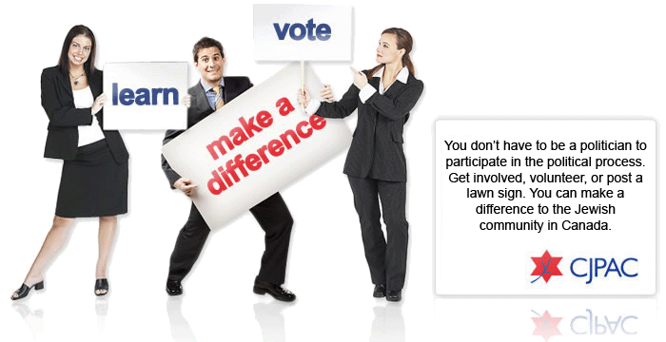
Please fax this form back to 416.929.0542 or email to info@cjpac.ca

