St. Thomas University Atlantic Human Rights Centre Presents
DR. BERNIE VIGOD MEMORIAL LECTURE
FROM HATE TO HOPE IN THE DIGITAL AGE
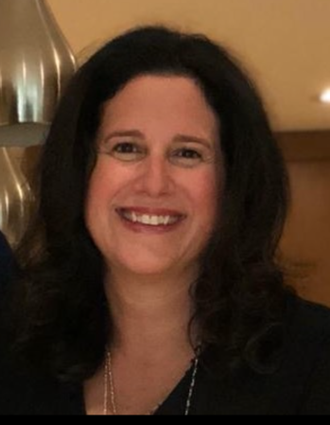
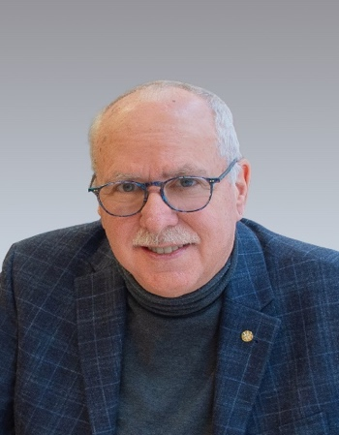

With panelists
Marc-Alain Mallet
Bernie M. Farber
Karen Shai

SPEAKERS
Marc-Alain Mallet is Director of the New Brunswick Human Rights Commission, which is responsible for administering the Human Rights Act. Mr. Mallet is a seasoned executive with over 30 years of experience managing programs in both the provincial and federal public sectors. He was previously Director of Commercialization and Strategy at the National Research Council Canada - Institute for Information Technology, responsible for its national business development activities. Prior to NRC, he led initiatives in various GNB departments; his last role was as Director of eNB.ca. Mr. Mallet is passionate about creating healthy, inclusive and innovative organizations for the betterment of New Brunswick; assessing the effects of emerging technologies on human rights; and ensuring the Commission’s efforts and its legislation remain relevant.
Bernie M. Farber has more than three decades focused on antisemitism, human rights, pluralism, and race relations. Recognized and called upon by the courts, media and law enforcement as an expert in human and civil rights, he is one of few in the field to be accepted by Canadian Courts as an expert in hate crime, antisemitism and white supremacy. Mr. Farber has indefatigably championed human rights and social justice issues as head of the Canadian Jewish Congress, the Paloma Foundation and the Mosaic Institute. Mr. Farber has also worked closely with Canadian Indigenous communities on historical redress. He is Chair of the Canadian Anti-Hate Network, is an advisory board member of Human Rights Watch Canada, chairs the Rights and Ethics Committee for Community Living Toronto, and is a former co-Chair of the antisemitism division of the Ontario Anti-Racism Directorate.
Karen Shai is a criminal prosecutor with the Ministry of the Attorney General in Ontario. Ms. Shai has worked as Crown counsel in the Crown Law Office - Criminal, Ontario's leading appellate office, since 1998. She served as counsel to the Assistant Deputy Attorney General (Criminal Law Division) from 2004 to 2008. She eventually became involved in hate crime work, leading a 2018 training session for designated hate crime prosecutors in Ontario. She regularly trains police officers in the investigation of hate crime. She currently serves as vice chair of Ontario's Hate Crime Working Group established in 2019 to address the rise of hate crime in Ontario. This group regularly provides advice to police and prosecutors throughout the province in the investigation and prosecution of hate propaganda and hate motivated offences.

DR. BERNIE VIGOD

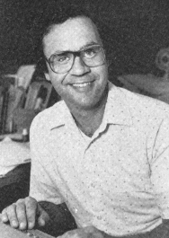
Canadian Historian and educator,
Dr. Bernie Vigod (1946-1988) was a lifelong advocate of human rights and civil liberties.
Born in Winnipeg, he was educated at the University of Manitoba, Carleton University and Queen’s University in Canada. In 1971, he joined the faculty of History at the University of New Brunswick, Canada where he taught for 17 years.
An outstanding teacher and scholar, Dr. Vigod was a Professor of History and Associate Dean of the University’s School of Graduate Studies and Research, as well as the New Brunswick member of the Social Sciences and Humanities Research Council of Canada.
Dr. Vigod served the cause of human rights with distinction. He spoke and published extensively on human rights issues. Dr. Vigod also acted as an advisor to public officials on human rights issues and took a leading role in organizations dedicated to promoting human rights. This lecture series is dedicated to his memory and features distinguished speakers on a wide range of human rights issues.

PROGRAM

Welcome
President Dawn Russell
St. Thomas University

Introduction of Panelists
Harry Forestell

Panel Discussion
Marc-Alain Mallet
Bernie M. Farber
Karen Shai

Questions
Harry Forestell

Announcement of Vigod Scholarships
Zena Simces
Recipients: Patrick Donovan and Caitlin Hyslop-Margison

Closing
Zena Simces and Simone and Michelle Vigod

