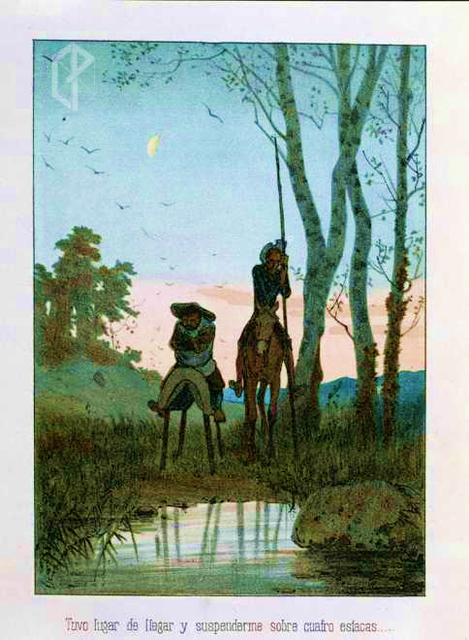
FIRST CALL FOR PAPERS
CERVANTES SOCIETY OF AMERICA
NORTH AMERICAN CONFERENCE
SEPT. 27-29, 2018
UNIVERSITY OF CALGARY
CALGARY, ALBERTA, CANADA

Plenary speaker: Mary Elizabeth Perry

Proposals for 20-minute presentations, in both Spanish and English, will be accepted on all topics related to Cervantes. There will be at least one session apiece on Cervantes and religion, and Cervantes and the ancient world.
Proposals should be a single page in length, containing both an abstract of less than 150 words and a brief curriculum vitae. Please send by Jan. 15, 2018, to Rachel Schmidt at rlschmid@ucalgary.ca.
Image courtesy of the Proyecto Cervantes, Texas A&M University.

