Travel to Ian N. Morrison Research Farm in Carman

Highway 3: two construction zones underway
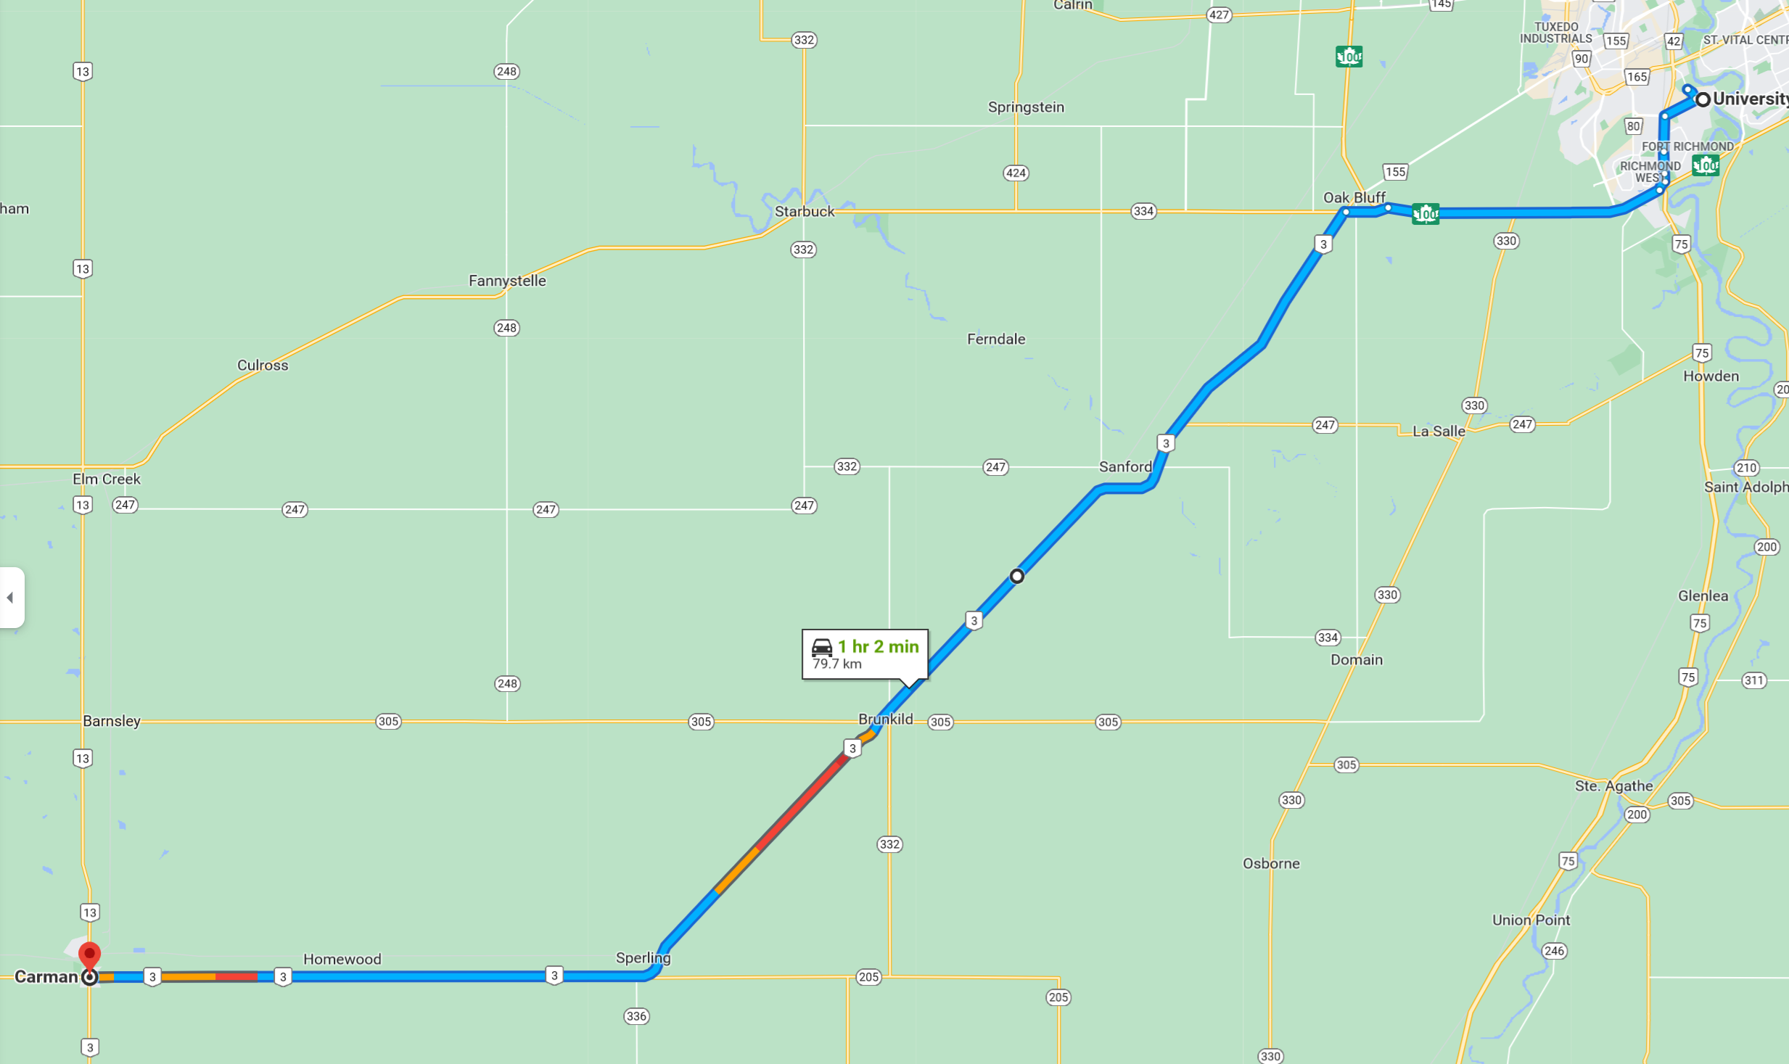

West on Highway 2 to Elm Creek, South on Highway 13 to Carman: also under construction between Elm Creek and Carman
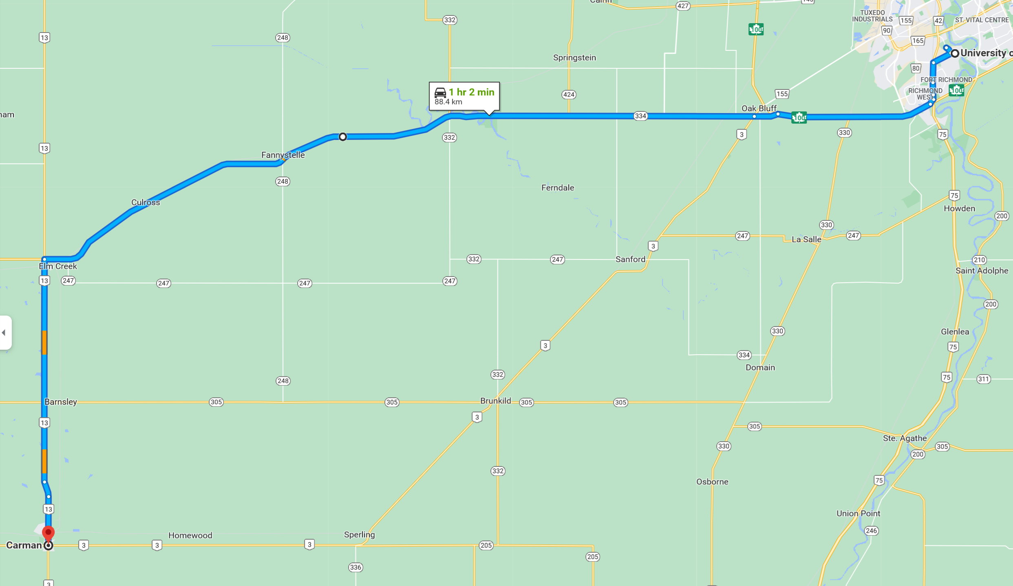

The farm is located on the western edge of Carman on Provincial Road 245.

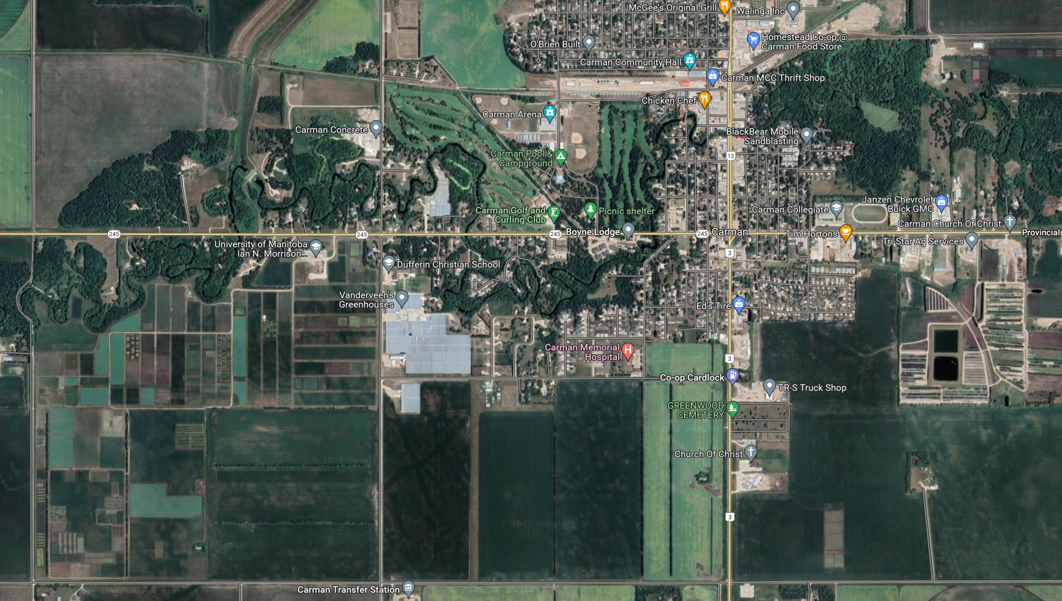
Highway 13
Highway 3
Entrance

