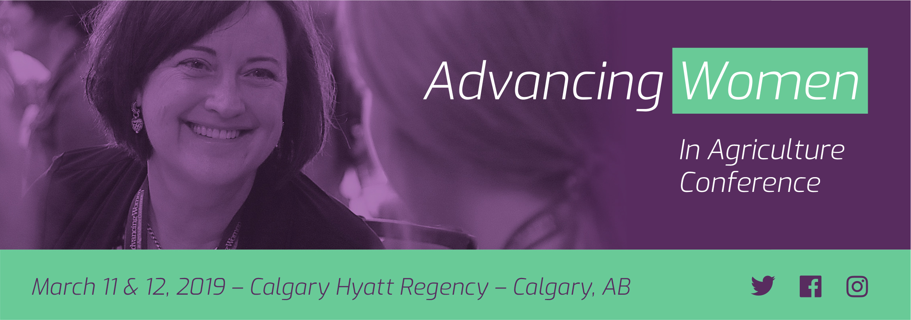

STUDENT APPLICATION FOR SPONSORSHIP to ATTEND AWC WEST 2019
DEADLINE FOR COMPLETE APPLICATIONS IS January 25, 2019
To complete the form: Click, fill in, save and send to events@irismeck.com
STEP 1 – Personal Details:
First Name:Click or tap here to enter text. Last Name:Click or tap here to enter text.
Permanent Address: Click or tap here to enter text.
Address: Click or tap here to enter text.
City: Click or tap here to enter text. Prov/State: Click or tap here to enter text.
Postal Code: Click or tap here to enter text.
Phone: Click or tap here to enter text. Cell Phone: Click or tap here to enter text.
Email: Click or tap here to enter text.

STEP 2 – Education Information:
Name of University/College: Click or tap here to enter text.
Current Status/Year of Study: Click or tap here to enter text.
Degree/Major: Click or tap here to enter text.
Department head contact info: Click or tap here to enter text.
Name: Click or tap here to enter text.
Title: Click or tap here to enter text.
Email: Click or tap here to enter text.
Address: Click or tap here to enter text.
Phone: Click or tap here to enter text.

Step 3: Please answer the following questions, answers will be posted on the AWC website.
Please describe your background, education and previous work experience.
Click or tap here to enter text.

Please explain why you are interested in attending the Advancing Women Conference and how you would expect the program to benefit your career objective.
Click or tap here to enter text.

Student Signature Date

STEP 4 – Application Checklist: Make sure you have provided us the following with your application.
☐ Completed application form (this form)
☐ A video (3-minute maximum, posted to YouTube and we ask that you provide us with a link to the video)
that describes your background, area of studies, career plans and why you think attending the Advancing Women Conference will be of benefit to your career objective.

☐ Head and shoulders, color photo suitable for publishing – please provide digital, in jpeg or pdf files. The photo must be at least 250 K in size.

Please return all required materials to: Email: events@irismeck.com

For further information, please contact us at: (403) 686-8407

PLEASE NOTE:
- The sponsorship covers two nights’ accommodations (Sunday and Monday) at the host hotel and your registration fee to attend the AWCA WEST 2019 conference (including Monday morning workshops, afternoon plenary, reception, banquet and networking coffee breaks; and on Tuesday breakfast, lunch, coffee breaks and all-day conference session).
- It is mandatory that you attend a morning workshop and the entire conference, or your sponsorship may be revoked and you will have to pay for expenses incurred.
- You will be responsible for all travel and additional expenses incurred. Plan for this prior to applying.
- No application will be accepted after the deadline date.

Terms of agreement: The conference will be recorded and photographed at the discretion of Iris Meck Communications Inc. Your application, registration and attendance at the event signifies your permission to utilize your image and/or likeness, name, university and city/province, and words spoken or written about the Advancing Women Conference in print, AWCA Website, AWCA YouTube and Instagram and online reporting prior to or post of the event for perpetuity. No limitations or restrictions apply.

