Level up your leadership with the President’s Student Leadership Program (PSLP)
Apply to become one of the 24 PSLP Fellows in 2026-27
Now recruiting for Cohort 8 | Deadline is March 6
• Unique, annual cohort-based program — the only one of its kind in Canada
• Inclusive and cross-disciplinary: applications open to students from all public universities and colleges in Manitoba, fully funded through a fellowship
• Learning from top professors, senior industry leaders and direct mentorship
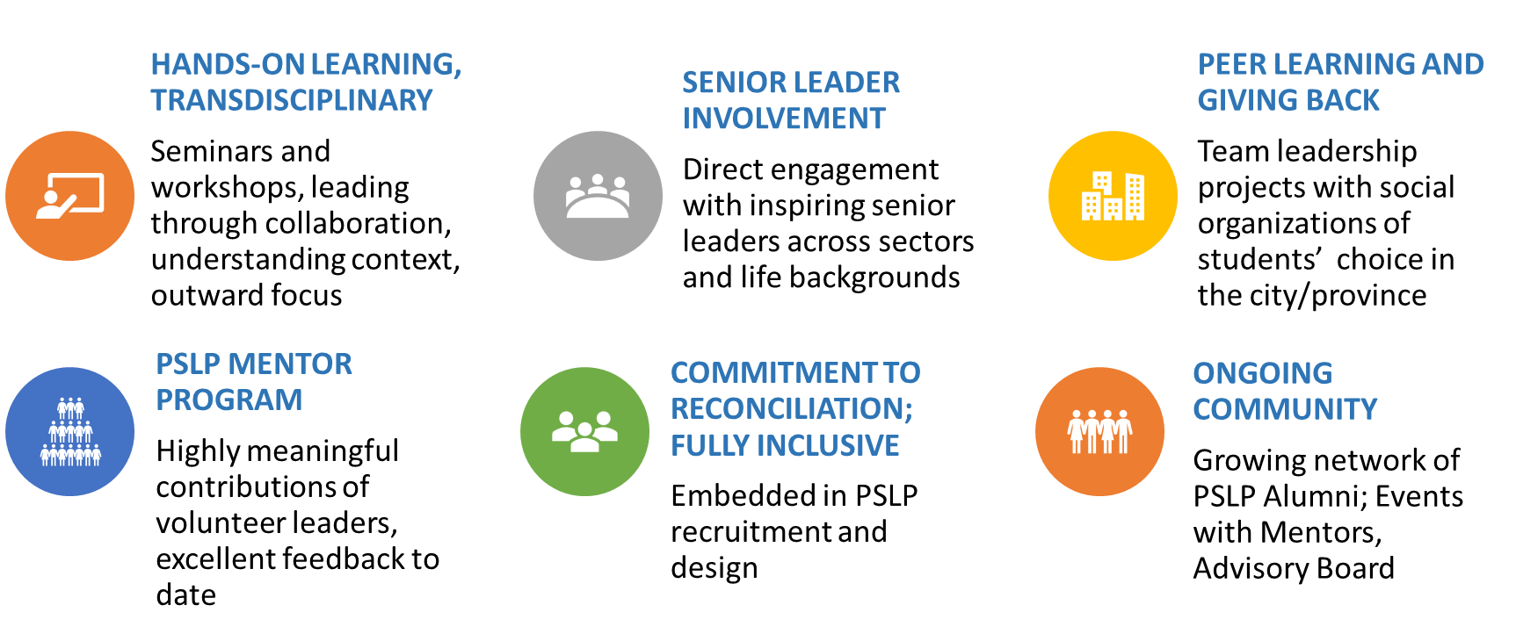
Who should apply?
Any MB postsecondary student with a record of commitment to leadership and a desire to learn more. Must have one remaining year in their program.
Call to Action for Academic Leaders: Share the opportunity, Shoulder-tap applicants
Applications open January 19 — deadline: March 6; Cohort 8 begins June 2026.
Web address: https://umanitoba.ca/asper/programs-of-study/presidents-student-leadership-program
For More information:
Melissa Gayle
Strategic Program Lead
James W. Burns Leadership Institute
University of Manitoba
Email: Melissa.Gayle@umanitoba.ca

