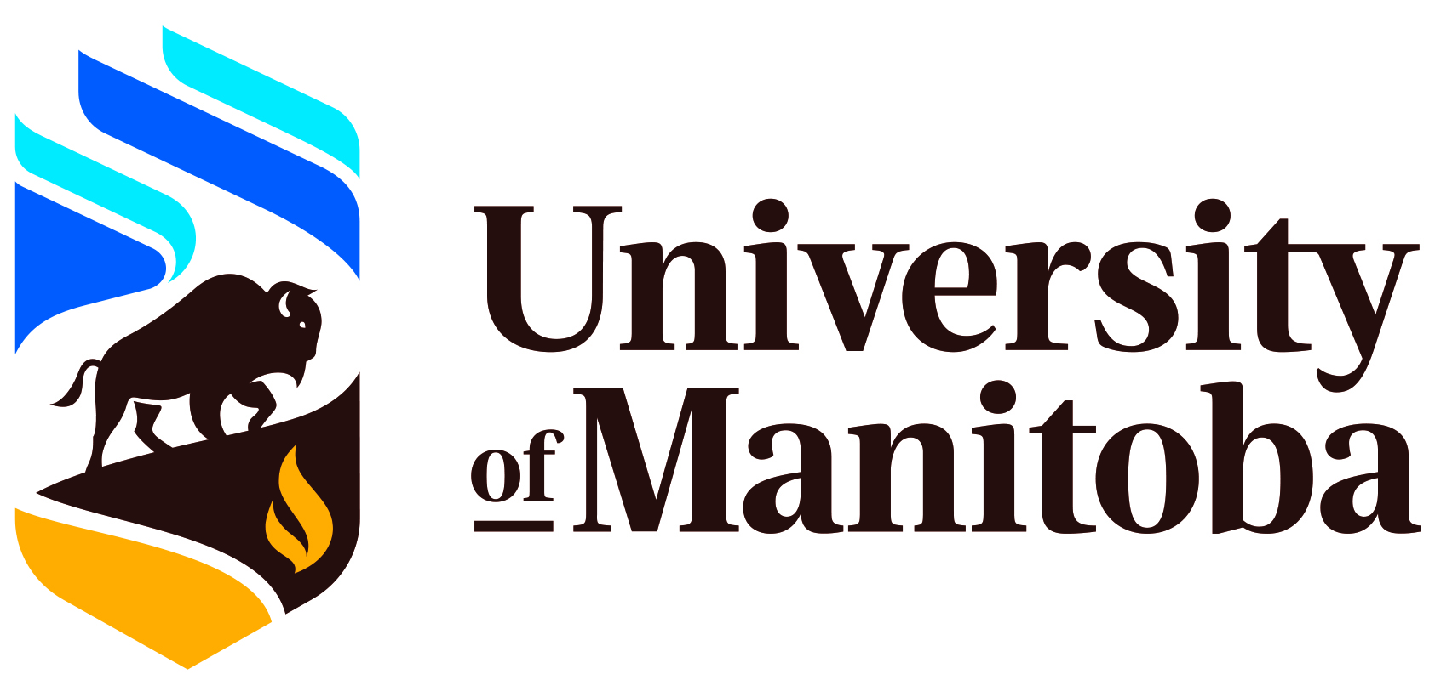
PSC In-service

The Promise of MDMA-Assisted Therapy

Tuesday, March 4, 2025, 3:00-4:30 pm
115 Fletcher Argue

Presented by
Dr. Darek Dawda, Ph.D., C.Psych.
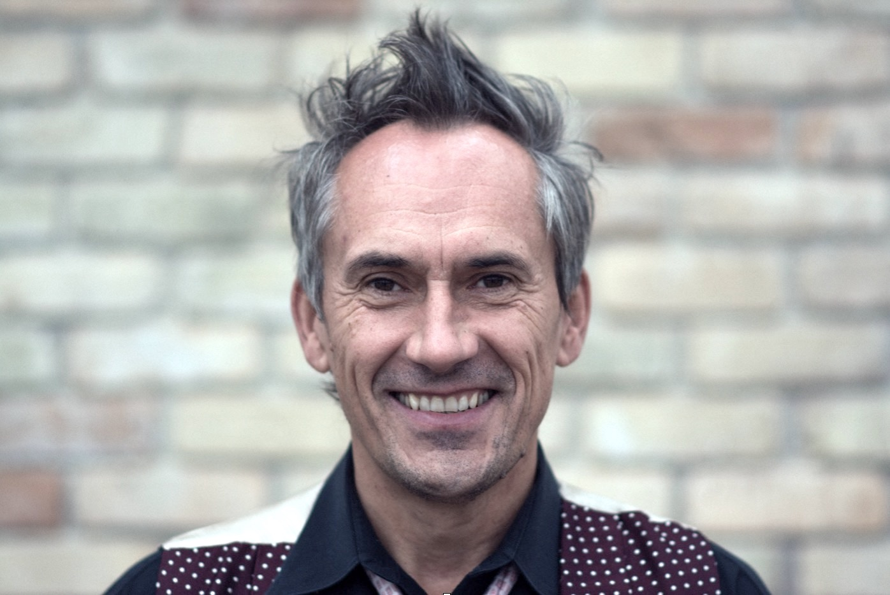
Darek Dawda is a clinical psychologist, mental health innovator, and host of wellness retreats. He is the owner and supervising psychologist at Prairie Psychology (prairiepsychology.ca) with over 20 years of experience working both as a psychotherapist and clinical supervisor to numerous other psychotherapists and psychology students. He is a MAPS-trained MDMA-Assisted Therapist, co-founder of Enhanced Therapy Institute (enhancedtherapy.ca), and host of MDMA Therapy Podcast, where he talks to world experts in MDMA-Assisted Therapy, including Rick Doblin and Gul Dolen. He is also an owner of a retreat center North Point Retreat (northpointretreat.com), and founder True You Retreats (trueyou.one), where he leveraged powerful therapeutic techniques to create optimal conditions for emotional healing, personal growth, and nourishing connections. In his everyday life, Darek has deep reflective personal practice that involves music, meditation, literature, stillness, pursuit of beauty and knowledge, and immersion in Canadian Shield nature.
This is an in-person event with Zoom attendance available in necessary.
RSVP to Andrea.Labossiere@umanitoba.ca by responding to the calendar invite (please let me know if you need to attend by Zoom).
Attendance is mandatory for all students doing their PSYC 7910/7920 practica at the PSC

