Clinical Psychology & PSC In-Service

An Introduction to Psychopharmacology for Psychologists
Tuesday, March 18, 2025 @ 3:00-4:30 pm
on Zoom

Presented by
Dr. Farhad Taremian
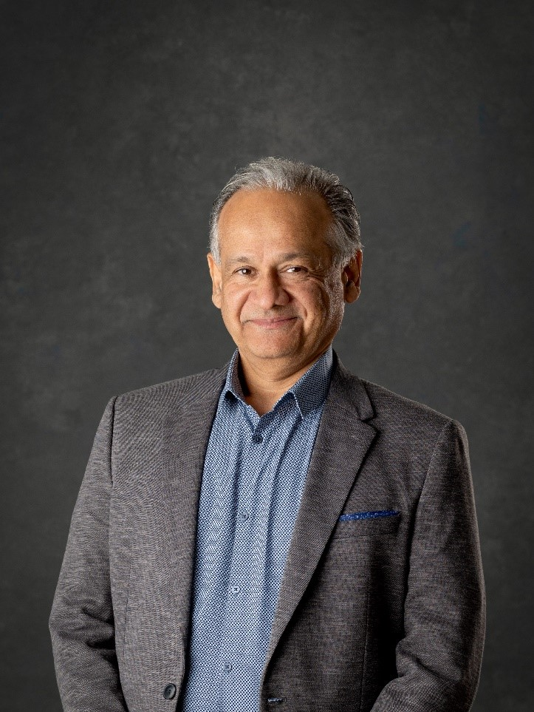

Dr. Farhad Taremian has over 25 years of experience working as a clinical psychologist. He uses cognitive behavioral therapy (CBT), schema therapy, and mindfulness techniques to provide comprehensive treatment for a wide range of psychological conditions including depression, anxiety disorders, obsessive-compulsive disorder, and post-traumatic stress disorder (PTSD). Dr. Taremian also has specialized training and extensive experience with addressing addictions and has completed a fellowship in addictive behavior at the University of London. Dr. Taremian works to develop individualized treatment plans that focus on both immediate symptom relief and long-term resilience for his clients.

Note: Attendance at this in-service is mandatory for all Clinical Psychology Grad Students not currently on residency to meet CPA Accreditation standards.

Please RSVP to Andrea.Labossiere@umanitoba.ca using the calendar invite.

