
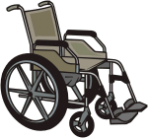
Does winter weather make it difficult for you or a family member to use a wheelchair or scooter?

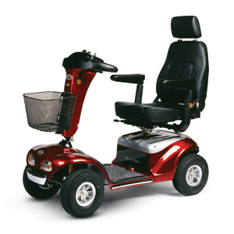
Are there changes that would help make using a wheelchair or scooter in the winter better for you?

If yes, we would like to hear from you

Occupational therapy researchers at the University of Manitoba are interested in hearing more about activities that are meaningful to you during the winter.

You can help by completing a survey.

- Go to https://www.surveymonkey.com/s/winterresearch to complete a survey completely on-line

OR
- Phone (204) 977-5617 or email winterweather.research@gmail.com for more information or to get the survey in paper-copy or do it over the phone

You will have the opportunity to enter in a draw to win a Tim Horton’s gift certificate for responding to our survey

