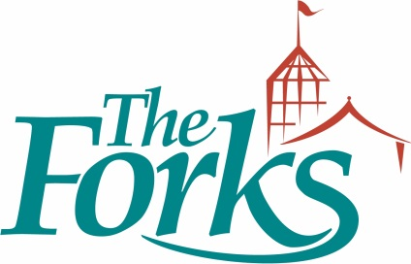

FUN AND FITNESS – THE BEST SUMMER JOB EVER!

If you are an energetic and physical fit individual who likes to interact with people, THE FORKS, Manitoba’s largest tourist attraction, has the perfect summer job for you.

We are looking to hire 4-6 Pedicab (bicycle taxi) Drivers to transport visitors at THE FORKS from one location to another on our site. This is a complimentary service to be made available on weekends for the month of June, and daily in July and August.

Our divers must be prepared to work outdoors at all times, represent THE FORKS in a professional, courteous and friendly fashion, and provide information about the available services at THE FORKS.

• 20 – 30 hours per week • 9:00 AM – 4:00 PM •$11 per hr, plus any tips.

Interested applicant should apply immediately to hr@tf-np.ca

