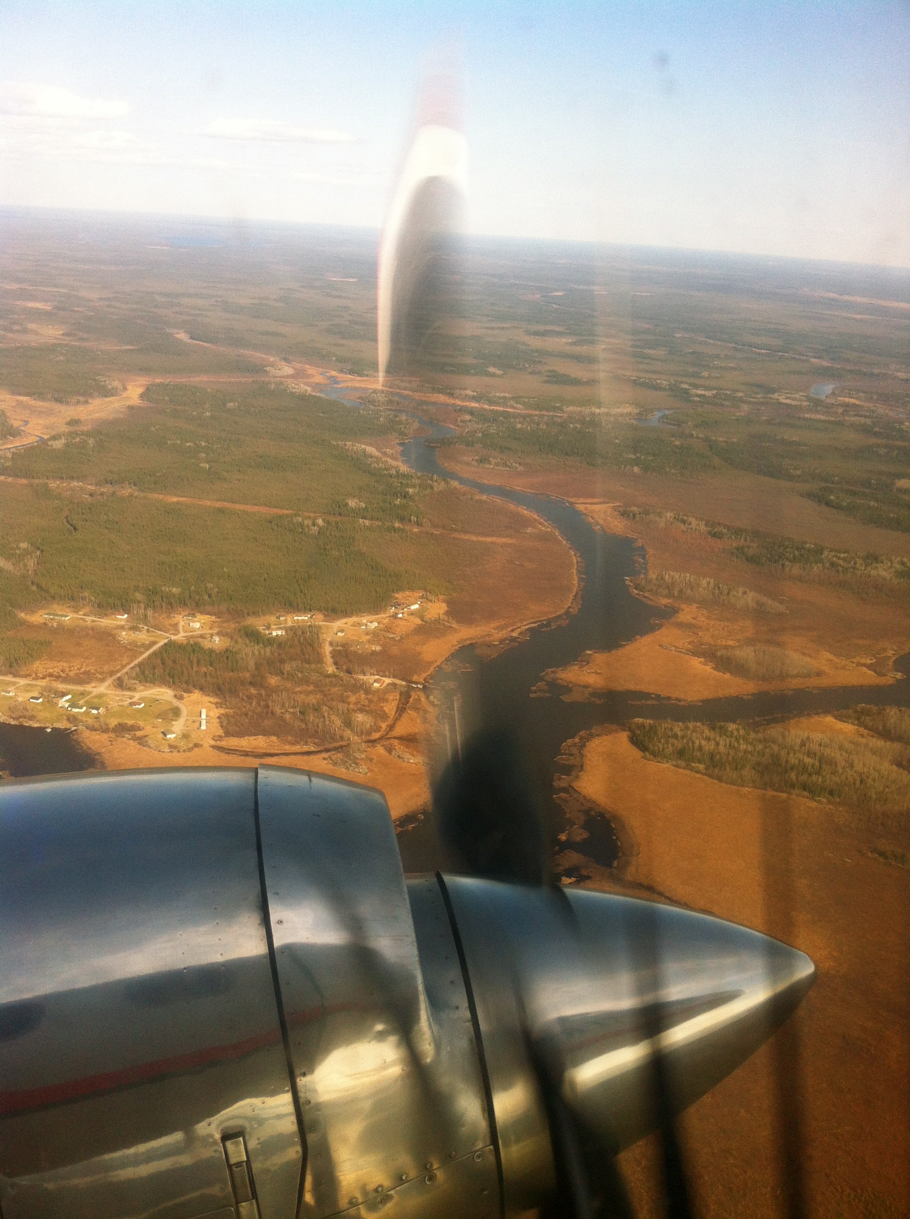
College of Community and Global Health
Bold Ideas Colloquium Series
Fall/Winter 2025/26 Speaker Abstract Form
Friday, Noon to 1:00 PM

Primary and Co-Presenter Information:

First name/Last name:

Organization/Unit/Centre/Program:

Email address:

List Co-Presenters (if applicable) and the organization/unit/centre/program they represent:

Short Bio:

Talk Details:

The talk is one hour. Using the speaker gives a 20-25 minute presentation, which is then followed by questions, comments, critical reflection.

Title of Talk
\

Lay Abstract (100 Words):
\

List Three Learning Objectives (Limit 15 words per objective):
1:
2:
3:

Presentation Date(s) (If a DATE has not been confirmed, then check 4 possible dates):
From the schedule, identify two possible presentation dates. Because we advance advertise, we ask that you formerly commit to the date selected.

- dd/mm
- dd/mm
Submit forms or for further information, contact:

Dr. Brenda Elias TBA
Director, Bold Ideas Colloquium Series Bold Ideas Colloquium Series Coordinator
Brenda.Elias@umanitoba.ca

