Department of Physical Therapy SharePoint Guide

The Department of Physical Therapy SharePoint site will be your central hub for all program-related information, resources, and updates. To get started, please ensure you’ve claimed your UMNet ID, as you’ll need to log in with your University of Manitoba account to access the site.
Getting Started:
- Visit the link below and bookmark it for easy access:
Department of Physical Therapy - Home

- When you first access the site, you’ll be prompted to log in: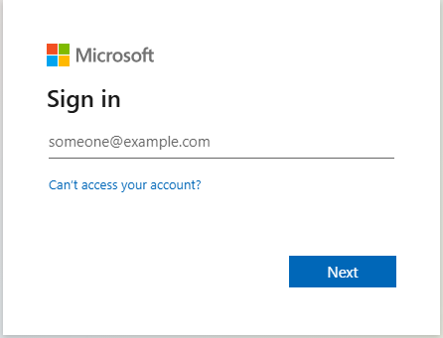
Important: Use your UManitoba account (personal accounts won’t be granted access).

- Once logged in, you’ll land on the homepage, which features:
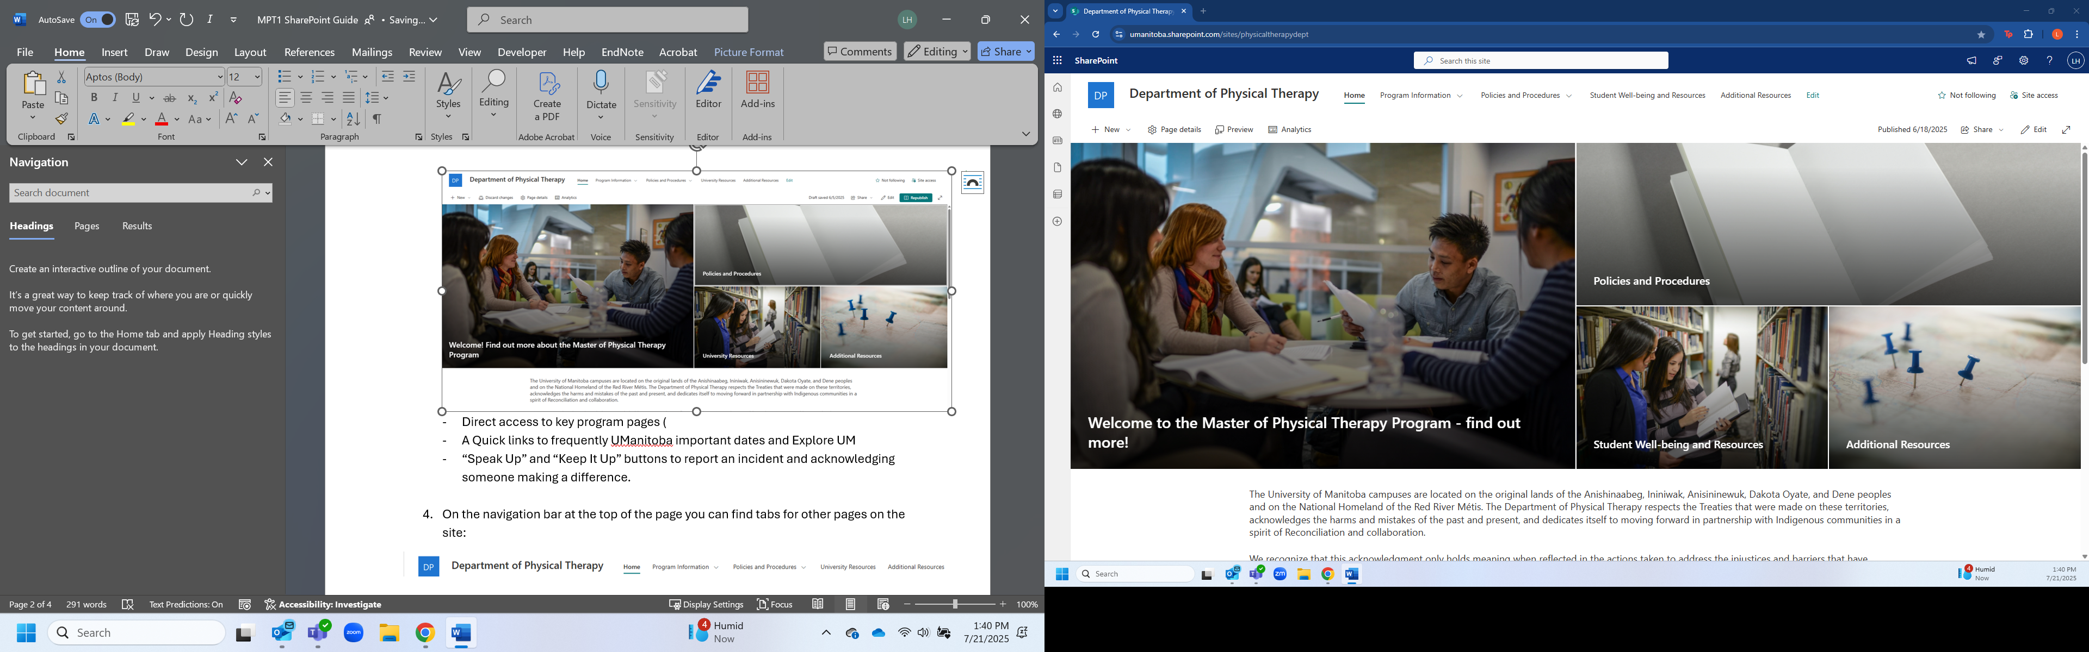
- Direct access to pages important to the PT program (e.g., Find out more, Policies and Procedures, Student Well-being and Resources, Additional Resources)
- A Quick links to frequently UManitoba important dates and Explore UM
- “Speak Up” and “Keep It Up” buttons to report an incident and acknowledging someone making a difference.

- On the navigation bar at the top of the page you can find tabs for other pages on the site:
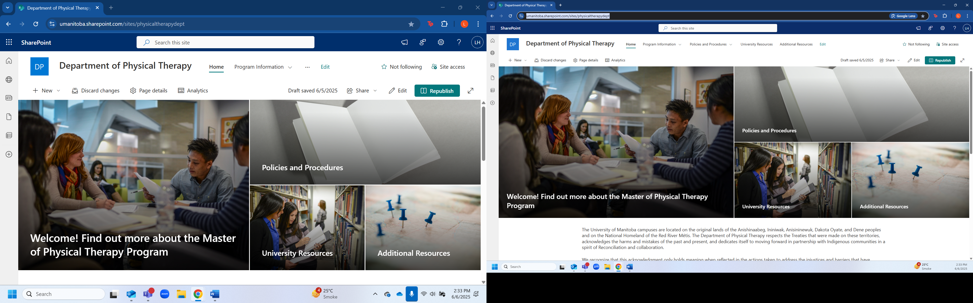

- Tabs with a dropdown arrow contain subpages for quick access. No need to click through multiple pages!
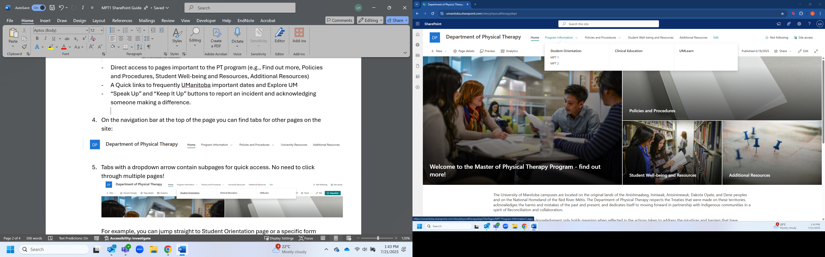

Key Resources You’ll Find on This Site
- The MPT Program Guide:
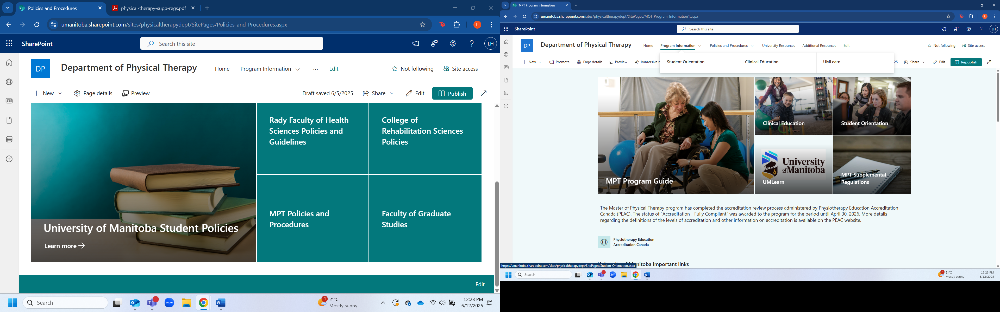
- Policies for exam deferral and brief and temporary absences:

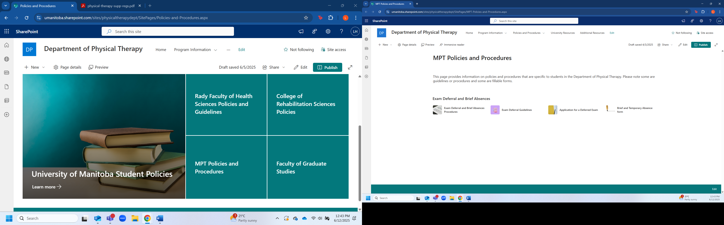

- Links to student resources including mental health supports:
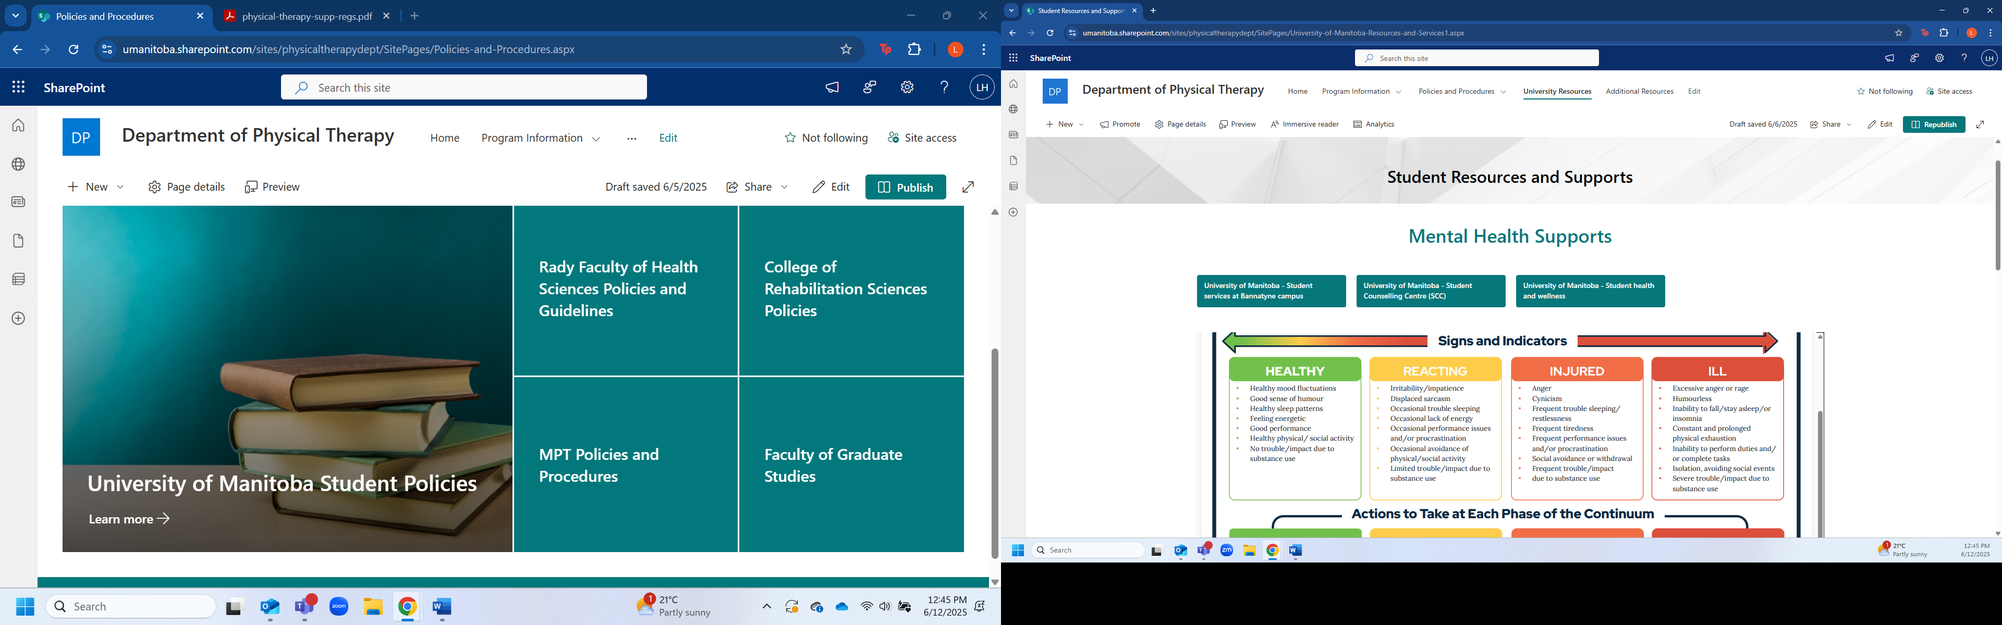

- A student-led page will also be added soon, featuring program news, upcoming events, and other updates curated by MPT students.

We’ve designed this site to make your experience as smooth as possible. Take some time to explore, and don’t hesitate to reach out to PTadmin@umanitoba.ca with “Dept PT SharePoint” in the subject line if you have any questions or would like to provide feedback.

