Dental Hygiene Student Attendee
Registration is OPEN!
Details for Student Promo Code providing Free registration - see below

  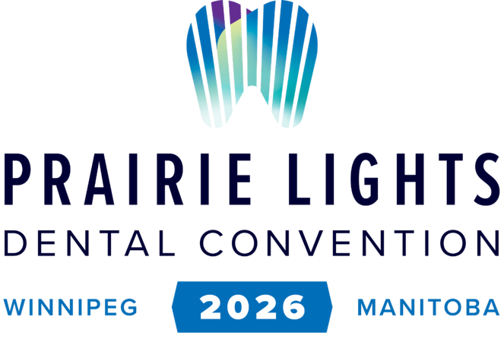
  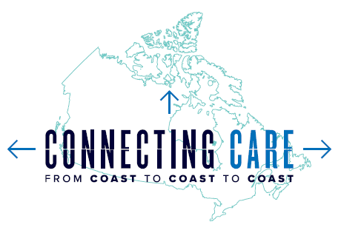

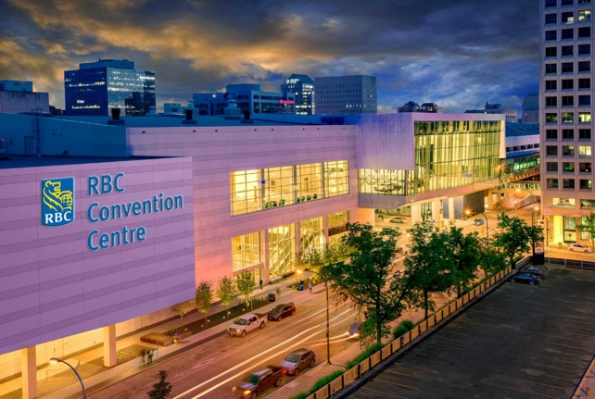

We encourage you to join us in Winnipeg, Manitoba April 16 - 18, 2026.

The MDA's Annual Convention & Trade Show will take place
at the RBC Convention Centre

Early Bird Registration ends on February 28th, 2026

Student Promo Code for FREE Registration
• You will be able to enter the Student Promotional Code as part of the completion of your registration.
• This promotional code is for student and grad students only and is to not be shared with any other individual that does not meet the criteria of Dental Grad Student - Dental College Student - Dental Assistant Student - Dental Hygiene Student.
• Promo Code - $tudents4Fr33
• This code provides you with free access to the general listing of lectures and trade show access. Breakfast & Lunch on Friday and Saturday are no cost. President's Gala is assessed an additional fee.

MDA Mentorship Convention Lunch and Presentations
Saturday, April 128h, 2026
11:30 am - 2 pm
• Please watch for upcoming details on Mentorship Case Study Sessions and Lunch that will take place on Saturday.
• The presentations and lunch will be for all 4 class years

Register as an Attendee

Thursday Keynote - Steven Page

Attendee - Frequently Asked Questions

