HSC Anesthesia Department Meeting Agenda
June 17, 2026
16:30-18:30

Join Zoom Meeting
https://umanitoba.zoom.us/j/68909777904?pwd=ZRrRdSgwyfC8m1T1Mj4kcroP1Lrefx.1
Meeting ID: 689 0977 7904
Passcode: 774884
- Welcoming remarks/Review agenda/call for new business
- Approval of minutes from December 18, 2025
- Professionalism
- Site leader’s report: M Tenenbein (pre-submitted)
    - Slate utilization summary
- Women’s Hospital: R Singh (pre-submitted)
- PCUS: E Bohn
- APS: A Grunfeld
- Pharmacotherapeutics: R Hardy (pre-submitted)
- PGME: K Staines/ C Loewen
- ACA Program: D Rodrigues
- Thoracic Anesthesia: K Ross-Hopley
- New Business
- Adjournment

HSC Anesthesia Department Meeting, June 2026
Site Leader’s Report
M Tenenbein: HSC Anesthesia Site Specialty Lead
Human Health Resources:
Currently around 3.0 FTE short, corresponding to around 10%.
Deficit being covered by department members picking up extra slates and double coverage of slates with ACAs
No patient cancelations due to Anesthesia unavailability, but rare closure of DCD due to anesthesia shortage. On days with forecasted shortages, we refrain from “scrambling” returned slates. Wednesdays continue to be our shortest day
Occasionally overstaffed, but no MDOs issued. Offers for VDOs are quickly claimed. When overstaffed, we “undouble” cover ND slates.
Anticipated departures include P Inglis (June) and S Kowalski (October). New hires who have already started include P Pries, L Grant, and M Maneluk. Upcoming new consultants include J Ridgeway, J Garber, E Vun, and K Cheung. New locums beginning shortly: T Butterworth, M Roznik, B Zhang, K Bangu. K Gray and G Buckley will have some consultant OR days during their fellowships (chronic pain and regional respectively). A Denisuik will continue to pick up clinical work during his fellowship and will have a consultant HSC fraction commencing December 2026. Overall, HSC appears to be on reasonable footing barring any unanticipated departures/LOAs. Congratulations to all those preparing to go on parental leave in the next few months.

Slate Utilization:
This is a region wide issue which impacts HSC greatly.
Still experiencing last minute slate returns despite published guidelines for slate returns. Additionally, there are appropriately returned slates which aren’t being picked up (especially Notre Dame slates for day surgery cases). This also mitigates the consequences of our FTE deficit.
DCD room closed on occasion due to nursing shortages and a high number of sick calls which result in DCD closing. Overall, we have seen a decrease in DCD slate guarantee claimed by HSC Anesthesiologists in fiscal year 2025/26 (630 hrs) compared to 2024/25 (903 hrs). Fiscal year is from April 1 to March 31st.
When filling out the slate guarantee smartsheet, please be as accurate as possible as to the reason why no cases were scheduled. If unsure, please check with the IHA plus/minus charge nurse. This is being tracked and evaluated. Remember, these slate guarantees are not included in the negotiated Physician Services Agreement. In order to claim the guarantee, a reasonable attempt should be made to provide billable services.
PACU:
Issues with respect to ICU overflow and holds remain a work in progress. The use of pre-op holding for up to 6 PACU patients has had some success, but has not eliminated PACU holds. This is especially true for patient who requires vasopressors, mechanical ventilation, and MRSA precautions. We have been seeing some extremely long PACU holds for these patients as of late. The overall cause is lack of in-patient capacity, which unfortunately does not have an easy solution.
PACU leadership has mentioned that some Anesthesiologists have been quite aggressive while on hold. Please remember to be as courteous as possible, as the charge nurses in PACU work extremely hard to minimize holds as much as possible.
Day surgery or short stay patients can bypass PACU and go direct to MS3 phase II recovery if all criteria are met. See attached. Remember, MS3 no longer does Phase I recovery.
PACU manager, Howie Chymyshyn has announced his retirement. We thank him for his service. A replacement has not been named.
Children’s OR 5 moving to Notre Dame:
AC05 was taken over by adult OR many years ago. At the time, it was meant as a temporary situation until new 2 theatres were built in KIAM. Due to adult slate expansion and challenges with human health resources on the pediatric side, that theatre has stayed with adult OR longer than anticipated. The current plan is for AC05 to be returned to Children’s OR this upcoming fall, and likely be utilized 3 days a week. In order to remain slate neutral, adult OR will schedule 3 slates in Notre Dame OR daily. Eventually, with greater utilization, ND OR case criteria will become similar to main OR, just like when gynecology operated there. The focus will remain on day surgery/ short stay cases with only the occasional SDA. The practice of double covering 2 of the ND slates with ACAs will continue in order to maintain a high anesthesia provider to slate ratio.
Cell Saver:
Perfusionists remain on call for HSC and available for pre-determined cases. Their HR situation has improved recently, and the possibility of an on-site presence at HSC may be possible in the near future. The best way to contact the perfusionist on call is to send a message via Tiger Connect. Just type “perfusion” in the recipient space. Plans to trial a new, fully automated cell saver machine are advancing slowly.
PAC:
As of late, I have received several complaints from well-meaning surgeons who have had patients cancelled for surgery without an explanation. As perioperative consultant physicians, we should be communicating to our surgeons in the unlikely event an operation needs to be postponed or cancelled. In the old days we used to frequently call surgeons, now Tiger Connect is also appropriate. We also need to document on the PAC sheet our decision and rationale. PAC admin will forward the PAC sheet to the surgical offices. PAC is expected to transition to electronic charting within this calendar year.
Maureen Gomez has vacated her position as PAC CRN in order to take a term managerial position at HSC. We are pleased that Shantee Siemens (recently IR, previous PACU nurse) has accepted this role, with a start date in late June.
A new prehabilitation clinic will be starting at HSC under the leadership of Raegan Cleven with assistance from Phil Pries.

Offsites:
Volumes remain high. I’m doing the best I can to schedule these as appropriately as possible. Over the past few weeks, we have gone live with a trial of an offsite ACA attached to the APS attending. Early reports have been overwhelmingly positive. In addition to adding a set of highly skilled hands in offsite locations, APS attendings are now able to leave offsite patients during stable periods of maintenance anesthesia to provide care to the APS patients. ACAs, APS physicians, and pain nurses are all extremely happy with how this trial has been going. PCUS continues to help out with offsites when APS becomes saturated. As a rule, PCUS attendings are not scheduled for offsite cases prior to 11:00 so that rounds can be completed. For recovery, if Phase I is required, these patients must go to PACU as this is the only location currently doing phase 1 recovery. MS3 is only appropriate for Phase II recovery. In both cases, you must call in advance of arriving to ensure a spot.
Jody Arjoon has a retirement date of July 31st. After her mandatory 8 week, she plans on returning to our department in a casual position which includes APS and PAC.
Scheduling:
Apologies for the late summer call schedule. We will work on distributing quarterly schedules 8 weeks in advance of the next period. We are often delayed in distributing our schedule due to having to wait for St Boniface. The advantage of regional scheduling software is that all schedules can be made/released simultaneously.
Due to short notice changes in theatre assignments, Equina and the OR schedule on occasion don’t match. In this event, Anesthesiologists should stay with the surgeon/service as per Equina, the theatre number is lowest priority.
Health Sciences Centre Update:
Hospital accreditation went very well. EPR is going live in Psych Health this August, followed by Child Health, with the remainder of the hospital set to convert within the year. Orders will be paper based for the time being. Anesthesia records will be paper until we transition to an Anesthesia Information Management system (AIMS) from Altera.

Department Funds:
Our fund currently has a healthy balance, allowing us to waive the usual $500 annual fee per department member this year. The fee will return in 2027 to help support a holiday party. We will also be going out for dinner with Dr. Kowalski in November as part of his retirement tour.

Co-Site Lead:
My term as HSC Site Specialty lead will come to an end on December 31st, 2026. That will mark 5.5 years in this role. In order to provide a smooth transition to the next site leader, there will be a call for applications for a co-site lead position with a start date this fall. After 3-4 months as co-site lead, the individual will transition to HSC Site Specialty Lead, effective January 1st, 2027.

Women’s Hospital Update: June 2026
Gyne OR
- Hypothermia
We have had several complaints from recovery room nurses in the last few months regarding patients who arrive in recovery with low core temperatures. Most of these cases have been the result of MIS cases that have gone longer than expected. I have prompted the nurses to ensure that patients who are booked for cases longer than an hour to have a Bair hugger applied intraoperatively. Please try and be vigilant about this going forward.
- New Equipment
We have just obtained a POC INR machine that will remain in preop holding. Our TEG analyser should be arriving in the next couple of months: please stay tuned for more updates on this.
Labour Floor
- Birth Tourism
This issue continues to be a point of contention. Shared Health is unwilling to assist us with the collection of fees where patients are uninsured, non-Canadian, non-residents of Manitoba who present exclusively for the purpose of having a baby in Canada. Physician billing services (PBS) is willing to help us collect fees where these patients are pre-identified by the OB offices. They will be referred to PBS and a fee of 2000.00 will be collected in advance and held by this office. We can then bill PBS at the approved rates discussed (5x the fee schedule). I will post the fee schedule in our office on the labour floor. It will take a little time to get all the OB offices on board, but at least this is helpful.
Remember that non-insured patients who live in Manitoba may be eligible for good faith billing, and PBS will not be collecting fees in advance for this category of patient.

- Labour floor volumes
I continue to explore ways to ensure that we have a second set of hands available to always help after hours. This remains an open discussion with no clear solution. The most realistic option at this time would be to schedule an in-house ACA for nights, but this is not presently plausible given our current ACA numbers.
- Epidural Trays
The supply chain disruption is resolved now. Thanks to everyone for putting up with the crappy sub trays!
- Cleaning and Restocking of the anesthesia cockpit.
After hours support continues to be problematic. I am advocating for a “lead hand” nights/ evenings position and ORA overtime shift allocation. Please fill out an RL6 whenever you encounter uncleaned equipment or are missing critical supplies as this is the only path to funding new positions and endeavors.
- Ward calls for IV starts
Please ensure that any nursing calls from the 4th or 5th floor for IV access are refused. For the anesthesiologist to be officially consulted for IV access, the call must come directly from the attending of record. This should effectively dissuade nursing from making unnecessary requests and redirect them in most cases into using the vascular access team instead.
- New Vocera Units
We have ordered 5 new vocera units for the labour floor given the poor condition of our existing fleet and their batteries. Please ensure that all our vocera units are signed out and returned to our team room. Lately I have noticed that our anesthesia vocera units are disappearing and reappearing in the central report room. As we pay for and maintain our departmental vocera units, it is important that they be signed out and returned within our own office. I will send out an email once we have the new badges in our possession.
Please feel free to reach out with any questions!
Renate

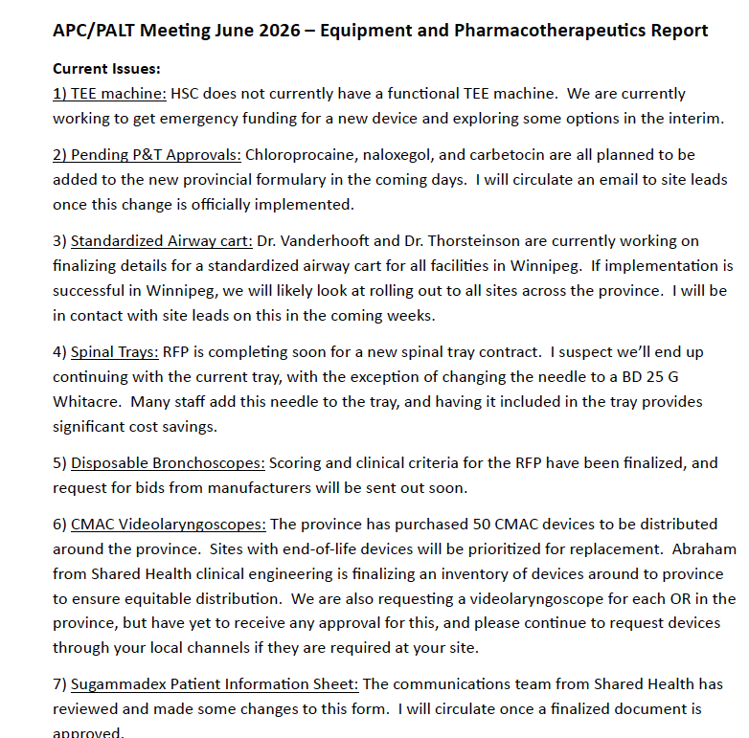
Rob Hardy
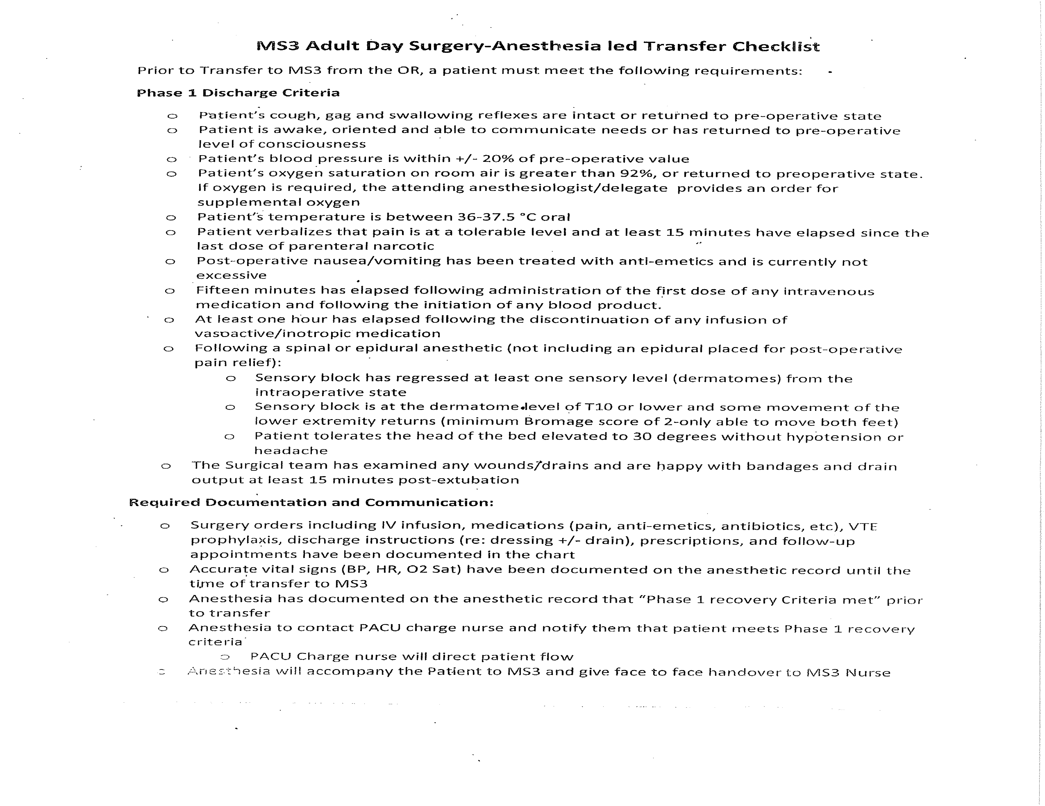



HEALTH SCIENCES CENTRE - DEPARTMENT OF ANESTHESIA

ADULT SECTION MEETING

Thursday, December 18, 2025 – 1700 HOURS Zoom

Chair – Dr. M. Tenenbein

NAME | PRESENT | REGRETS | NAME | PRESENT | REGRETS | NAME | PRESENT | REGRETS | NAME | PRESENT | REGRETS
Dr. K. Baron |  | X | Dr. A. Geisheimer | X |  | Dr. T. Mutter | X |  | Dr. I. Sutton |  | X
Dr. M. Bhangu | X |  | Dr. J. Gill | X |  | Dr. P. Mykytiuk |  | X | Dr. M. Tenenbein | X
Dr. E. Bohn | X |  | Dr. P. Govender | X |  | Dr. S. Neily | X |  | Dr. L. Vanderhooft | X
Dr. M. Bourrier | X |  | Dr. A. Grunfeld | X |  | Dr. C. Papadimitropolous | X |  | Dr. J. Webar | X
Dr. R. Brinkman |  | X | Dr. L Grant |  | X | Dr. R. Pauls | X |  | Dr. K. Williamson |  | X
Dr. R. Brown |  | X | Dr. C. Haberman |  | X | Dr. A. Petropolis |  | X | Dr. V. Wourms |  | X
Dr. R. Cleven | X |  | Dr. T. Hall | X |  | Dr. C. Pickering | X |  | Dr. P. Wtorek | X
Dr. B. Csupak |  | X | Dr. R. Hardy | X |  | Dr. J. Plester | X |  | Dr. S. Young |  | X
Dr. R. Debrouwere |  | X | Dr. P. Inglis | X |  | Dr. P. Pries |  | X | Guests:
Dr. M. Deck |  | X | Dr. M. Klemmer |  | X | Dr. R. Raban |  | X | Katie Hall Hursh | X
Dr. A. Denisuik | X |  | Dr. K. Kuo |  | X | Dr. A. Reda |  | X
Dr. T. Denisuik | X |  | Dr. S. Kowalski |  | X | Dr. C. Reich | X
Dr. L. Docking | X |  | Dr. C. Loewen | X |  | Dr. S. Richardson |  | X
Dr. J. Dundas |  | X | Dr. K. McPhail |  | X | Dr. D. Rodrigues | X
Dr. J. Enns |  | X | Dr. M. Maneluk |  | X | Dr. K. Ross-Hopley | X
Dr. R. Foyle | X |  | Dr. A. Martin | X |  | Dr. F. Siddiqui |  | X
Dr. S. Frost | X |  | Dr. A. Mathieson |  | X | Dr. E. Simonsen | X |  | Gen Krahn - minutes | X
Dr. D. Funk |  | X | Dr. H. McDonald | X |  | Dr. R. Singh | X
Dr. S. Gard |  | X | Dr. I. McIntyre | X |  | Dr. K. Staines | X

 | ITEM | DISCUSSION | ACTION/  FOLLOW UP
1 | Call to Order | The meeting was called to order at 1704 hours
2 | Approval of Minutes | Motion to approve minutes Dr. Bohn seconded by Dr. Singh
3 | HSC Foundation:  Katie Hall Hursh | Recap on Operation Excellence - Robotic surgery, Pain Clinic to MB Clinic, 14 Bed PCUS, Ultrasound Machines, TEE  Monthly donor program for any clinicians that would like to participate.  Radiothon – Department Challenge  https://host.nxt.blackbaud.com/adaptive-donor-form/?formId=c853981c-688d-41b8-b13e-b9a184bd8fde&envid=p-kpAl1c5caEiUT2kDGAncQw&zone=can&desid=297&appealid=866&campaignid=48  Call for interest for those that want to attend Savour Mexico: Wine & Food event Feb 21-26
4 | Professionalism | Reminder on professional of all staff, especially in “at risk” locations such as the Anesthesia team room
5 | Site Leaders report | - Recap of pre-submitted report.  - Review of Notre Dame exclusion criteria.  - Anticipated awake intubation should be added to the exclusion list  - Review of E2 criteria, connect with physician to confirm urgency if in doubt from resident referral. Attending to attending discussions  - Call schedule. Attendings assigned call (not locums), but all can pick up calls on offer in Equina.  - A9 Default settings: Increase rate to 12, increase volume to 500  Change setting to flow sensing  - Ultrasound machines coming to trial  - Associate Site Lead, Anes – HSC, posting in Sept 2026.  Site Specialty Lead, Anes – HSC, posting for transition Jan 2027. Hold for details  - Back up – should not be paired with Coilings or Notre Dame slates. | Dr. Tenenbein to talk to BomiMed rep & Mindray rep
6 | Women’s Hospital | Recap of pre-submitted report
7 | PCUS/PAC | New Medical Manager of PCUS effective January 1st – Dr. Ethan Bohn.
8 | Acute Pain Service | New order sets for epidurals coming up.
9 | Pharmacotherapeutics & Equipment | - Trial of new spinal trays coming up.  - There may be a change in LMAs
10 | PGME | - New orientation package for Off-service residents has been distributed.  - PCUS resident orientation package was updated and distributed Dec 18-25.  - Resident safety. HSC staff member (non-anesthesia) was using a call room allocated to residents. Code to door has been changed. Bank of scan locks for facility pass swipe access may be an option  Call for CaRMS interviewers – Bhangu, Hardy, Martin, Singh, Tenenbein
11 | ACA Program | Recap of pre-submitted report  Discussion on needing to provide more direction to the physician extender group to ensure proper utilization. IHA to manage work allocation
12 | Thoracic Lead | Kate Ross-Hopley is taking over the Thoracic Lead position at HSC January 1st.
13 | New Business  Dr. Govender | Team Broken Earth – Dr. Sigurdson looking for an Anesthesiologist to join to go to Guatemala. Gyne and Pediatric cases. Option for resident to join as well.
14 | Adjournment | Meeting adjourned at 1905 hours  Adjournment moved by Dr. Grunfeld , seconded by Dr. Singh

