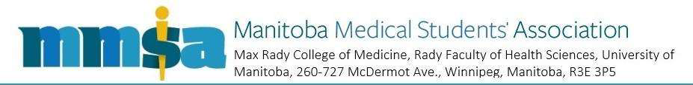
MMSA Student Initiative Grants Program

Student Initiative Grants Program Application Form

Instructions
Questions and applications can be directed to vsi.mmsa@umanitoba.ca.

Applications to be submitted with the following subject:
“MMSA SIG 2025-26 Fall Application: Initiative Name”.

Applications due October 31, 2025 at 23:59 CST in Word format.

Contact Information
Initiative Name: Click or tap here to enter text.
Primary Applicant Name: Click or tap here to enter text.
Co-Applicant Names: Click or tap here to enter text.
Primary Applicant Graduating Year: Click or tap here to enter text.
Contact Email: Click or tap here to enter text.
Contact Phone #: Click or tap here to enter text.

Declaration
By signing below, I hereby acknowledge that:
- I am a medical student at the Max Rady College of Medicine, University of Manitoba.
- My initiative adheres to all eligibility criteria and other guidelines outlined in the Student Initiative Grants Program Guidelines.
- The information provided below is accurate to the best of my knowledge.

_____________________________________________________
Primary Applicant Name

_____________________________________________________
Primary Applicant Signature

_____________________________________________________
Date
Initiative Details

Please summarize the initiative, including its objective(s) and how it will accomplish said objective(s).
Click or tap here to enter text.

Please describe how the initiative will enhance the experience of Manitoba medical students with respect to their education, wellbeing, or otherwise.
Click or tap here to enter text.

Please describe how the initiative will enhance your local, provincial, and/or national community.
Click or tap here to enter text.

Please describe the initiative’s proposed timeline from start to completion, including steps already taken.
Click or tap here to enter text.

Budget

Item | Description | Timing of Cost | Cost | Other Funding | Requested Funding
e.g. Food for attendees | Pizza ($5 x 30 attendees) | May 2018 | $150.00 | $50.00 from bake sale | $100.00
 |  |  | Total Cost: | Total Other Funding: | Total Requested:
*Add lines as necessary. A maximum of $1000.00 may be requested.

