UM Phased Approach to The Re-Opening of Research During COVID-19: Phase 2
________________________

This phased approach to the re-opening of research† applies only to research that must be conducted in university research spaces, including physical campuses and university-operated field sites. This phased approach does not apply to research that is conducted remotely. Research personnel are encouraged to conduct research remotely to the extent practical.

This document, which was developed from similar documents at other U15 institutions, consists of 3 parts: Guiding Principles, Preventative Measures, and Process.

A. Guiding Principles
- The health and safety of students, staff, faculty and visitors is the over-arching priority.
- All students, staff and faculty will work remotely unless approval has been granted to work on campus.
- Any activity on campus, whatever its nature, will be carried out while strictly respecting the constraints of public health authorities and in accordance with government guidelines and directives.
- Recovery of on-campus activities will be gradual and in keeping with the University’s stated principles and recovery plan.
- The University will continue to take into consideration and accommodate special circumstances for staff, faculty and students, including health conditions.

B. Preventative Measures
- Each of us has a role to play to reduce the virus from spreading – continued observance of these prevention measures will result in the timely restoration of services and easing of restrictions:
- Stay informed and follow public health directives.
- If you experience any symptoms of COVID-19 or have been exposed to someone diagnosed with COVID-19 stay home. See the screening tool for COVID-19.
- Limit your access to campus facilities and spaces for essential activities only.
- Health screening will play a role in assessing access to most facilities.
- Continue to practice good hygiene (hand washing, avoid touching your face, cough into your sleeve, disinfect frequently touched surfaces).
- Maintain a physical distance of not less than 2 meters and do not exceed one person per 10 m²
at all times.
- Masks are not a substitute for physical distancing, good hygiene or monitoring your health. Do not go to campus when you are sick, even if you are wearing a mask.
- Wear a mask or other appropriate face covering if you are unable to maintain the 2-meter distance. Wearing a mask is strongly encouraged when working in the proximity of others, even when the 2-meter distance is maintained. Cloth masks are acceptable as they protect others from you, should you be infected but still pre-symptomatic.
- Ensure frequent disinfecting, especially of high-touch surfaces and objects.

C. Process
Research activity will be increased in Phase 2 through the following process:

- The operationalizing of increasing research activity (including field work) within each faculty is the responsibility of each faculty. Therefore, each faculty will be asked to agree to increased research activity within their units, recognizing that different units may have different needs or impediments. The Offices of the Vice-President (Research and International), Environmental Health and Safety, as well as Risk Management and Security, can provide advice but the scope of Phase 2 make it impossible for any other unit but faculties to operationalize.
- Researchers in units where increased research activity is welcome will be invited to apply for resumption or commencement of research activity, using a form outlining the following:
  - Information regarding the principal investigator (name, department, contact info);
  - The member(s) of the research team to return; given all members of the research team may not be able to return, each PI will provide a ranked order of return for each member;
  - The amount of on-campus time required by each member(s) and, if applicable, whether members will overlap;
  - The reason member(s) should (re)start without delay;
  - Any consequences of further delaying the work; and
  - The contingency plan in the event the work must end (e.g., due to renewed government restrictions or illness amongst team members).
- Each unit head (starting at the departmental level, if the faculty is departmentalized) will review the requests and rank them; these requests will then be forwarded to the respective faculty’s dean’s office.
- Each faculty will review and rank the forms then forward them to the Vice-President (Research and International) for final approval and sign-off.
- The VPRI’s final approval will include confirmation with Safety Resources and the EHSO that there are no valid impediments to the activity proceeding and to set a target date for resumption of the research activity, to ensure proper coordination across campus (including with Physical Plant and Facilities staff).
- At each phase, the key priority will be approving time-sensitive and deadline-driven research. Priority will also be given to research activity involving grad students close to completing their degree and postdocs close to completing their term of appointment.

APPENDIX A

A1. Field Work Decision Tree
Field work must be approved by your ADR and the Vice-President (Research and International) using the Continue Research Request Form. The decision tree below will determine whether you may be eligible to continue field research. The expectations outlined on the next page will assist you in completing the form and your field work plan.

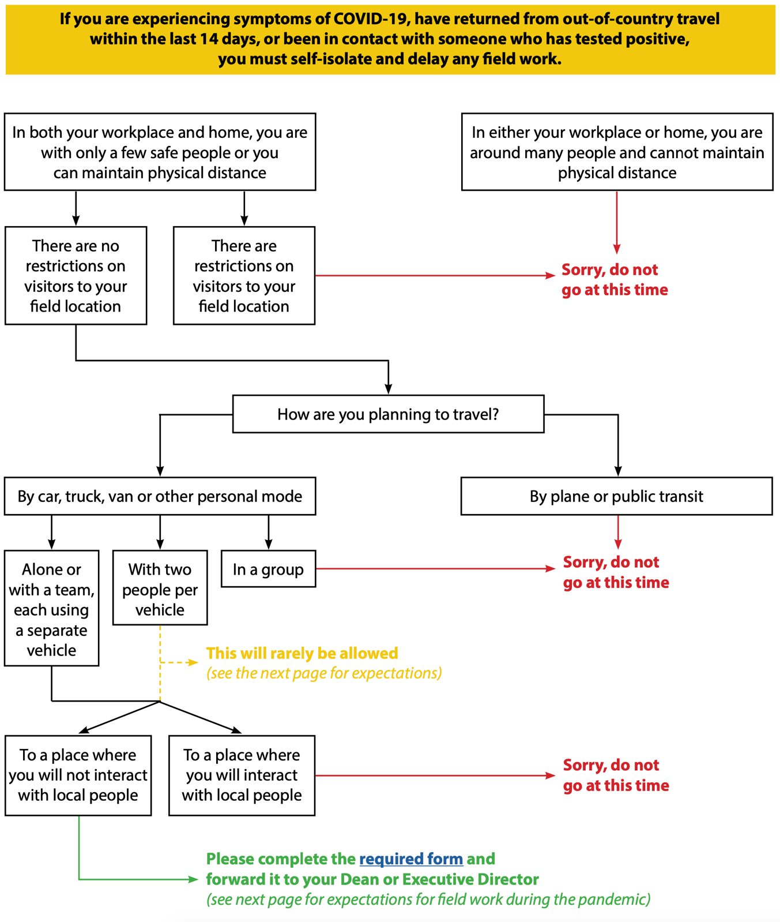
Please complete the Continue Research Request Form and forward it to your ADR. Please see the below for requirements for field work during the pandemic.

Requires permission of ADR and VPRIO

APPENDIX A

A2. Field Work Protocols
- Given the extent of the COVID-19 pandemic, we must limit the amount of research activity that cannot be undertaken remotely. If your field work must proceed, you will need to use the Continue Research Request Form to describe:
- Why the activity must proceed (i.e., the consequences of suspending, delaying or modifying the work); and
- Your health and safety plan for all research personnel (taking into account the expectations outlined below).
- The research team should be limited to the absolute minimum number of people required to perform the duties. Participation must also be entirely voluntary.
- Whenever possible, all research team members should self-isolate for 14 days prior to commencing field work.
- All research team members must:
- strictly follow all provincial health directives;
- practice appropriate physical distancing (at least two meters between individuals);
- regularly wash their hands with soap and water or using an alcohol-based hand sanitizer;
- avoid touching their eyes, nose and mouth with unwashed hands; and
- regularly monitor for COVID-19 symptoms (e.g., fever, cough, sore throat, shortness of breath).
- If any research team member experiences symptoms, they should immediately refrain from field work, self-isolate, and use the Government of Manitoba’s self-assessment tool to determine whether they should be tested. Because all research team members are expected to strictly adhere to distancing and cleaning requirements at all times, other team members should be able to continue field work.
- It is preferable for research team members to travel individually in vehicles. In situations where vehicles must be shared, and only when the ADR and Vice-President (Research and International) approve, multiple passengers may be allowed; in such cases, both occupants must have self-isolated for 14 days prior to the trip, the passenger must be seated as far from the driver as possible, both occupants must wear masks for the duration of the trip.
- Any meals must allow for appropriate distancing and avoid sharing of any utensils (i.e., buffet tongs or spoons).
- Where overnight stays are required, all research team members must have individual accommodations.
- Research team members must have appropriate supplies to thoroughly and regularly clean vehicle surfaces and equipment, including before any use by other team members.
- While in the field, the research team must:
- have access to essential services, including grocery stores and gas stations [NB: In keeping with guidance from provincial health authorities, only one research team member should be tasked with accessing these services and should do so with limited frequency];
- bring their own toilet paper, hand sanitizer, and other personal hygiene products;
- bring required prescription drugs and medical supplies before travel;
- gas up before leaving home;
- pack out what was packed in and leave no trace;
- All research team members must also know how to access the nearest hospitals and emergency medical services. Research team members should not use local health providers, unless it is an emergency.
- While in the field, the research team must be able to monitor, on a daily basis, any new directives from public health authorities or university administration, or they must be able to keep in daily contact with someone that can provide any such updates.
- Principal Investigators must have a contingency plan in place in the event you and/or your research team cannot continue the work (e.g., due to illness, new government restrictions, new university directives, or other factors beyond your control). Where research involves animals, your contingency plan must address animal welfare and ethics concerns.

† The term research is used herein to refer to all types of research inclusive of scholarly works and creative activities

