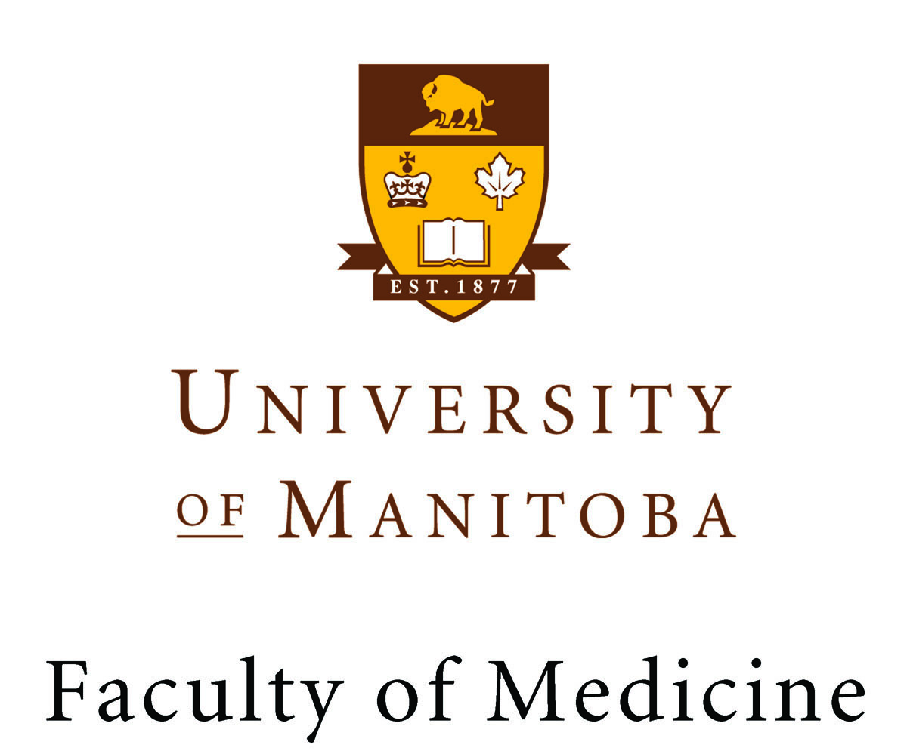

Public Lecture:
Neuroscience Research Program Candidate

Dr. Rao M. Adibhatla

"Neuroprotection in CNS Injuries: Therapeutic Options and Challenges”
DATE: Thursday, April 26, 2012
TIME: 9:00 AM – 10:00 AM
LOCATION: Theatre “C” – Basic Medical Sciences Building

Dr. Rao Adibhatla: Research Faculty - Department of Neurological Surgery,
University of Wisconsin-School Medicine and Public Health

Everyone welcome

For more information, contact Dr. Kevin Coombs, Neuroscience Research Program, and Faculty of Medicine
at (204)789-3375 or kcoombs@cc.umanitoba.ca

