Extending a warm welcome to you and your colleagues to join us at the Catalysts for Care 2026 Nursing Grand Rounds Speaker Series!

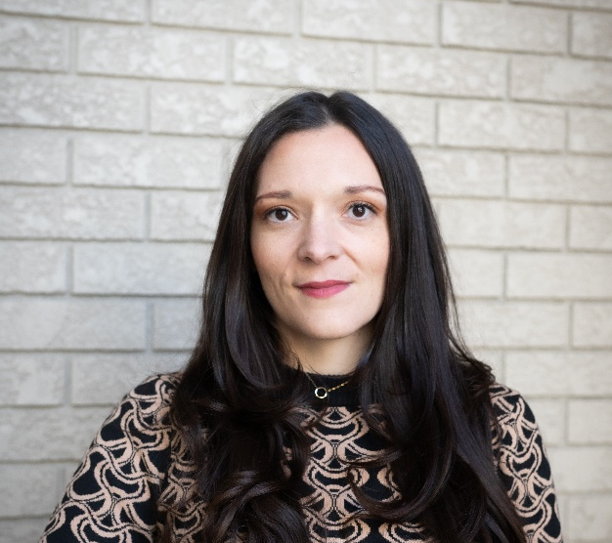
Date: April 14th, 2026, 12:00 – 1:00 pm, ZOOM presentation. Central Time Zone - Daylight Saving Time
Presenter: Josie Bolianatz, RN, MN, Lead, Clinical. Ontario Health.

Title: Becoming a Nurse: Pedagogical Care and Professional Formation in Nursing Education.

ZOOM LINK: https://ca01web.zoom.us/j/67075400127?pwd=KmEp7gAlT280fpW2qARqiaXaG5qCJK.1

Abstract: Becoming a Nurse: Pedagogical Care and Professional Formation in a Concept-Based Curriculum
Becoming a nurse is a transformative process that shapes an individual into a professional way of being in the world. This presentation shares research findings that explore how nursing students experience this process of professional formation within a concept-based curriculum (CBC), an educational model developed through student-centered and constructivist approaches to support deep learning and critical thinking.
Guided by phenomenology and Wenger’s Social Theory of Learning, this study examines the lifeworld of nursing students to understand how professional identity develops within contemporary nursing education. Using van Manen’s phenomenology of practice and conversational interviews with final-year students, the research illustrates the lived experience of learning the nursing profession.
Becoming a nurse is conceptualized as unfolding through a dynamic interplay between personal transformation and the structural conditions of education. Central to this process is pedagogical care—the relational way educators encounter and influence learners. Pedagogical care shapes how students come to understand themselves, others, and the meaning of nursing.
This presentation demonstrates how a philosophical lens can generate practical pedagogical insight. It invites nurse educators and academic leaders to consider how intentionally designed learning environments can support professional formation and strengthen nursing’s capacity to meet complex healthcare challenges.

UPCOMING PRESENTATIONS

Tuesday May 12th, 2026 9:00 – 10:00 am, Central Time Zone. (Nursing Week, live at the Desautel Concert Hall UM and by Zoom!)
Dr. Greta G. Cummings, RN, PhD, FCAHS, FAAN, FCAN, Professor & Principal, CLEAR Outcomes (Connecting Leadership, Education & Research) Outcomes Program, Faculty of Nursing, University of Alberta. From Insight to Impact: Advancing Nursing’s Future Through Research.
https://ca01web.zoom.us/j/65917807310?pwd=JUzYIQvm7tGgZu5IEbZqT9IXpQeqz9.1
Meeting ID: 659 1780 7310
Passcode: 446011

INVITATION TO PARTICIPATE – Your feedback is welcome!
We are conducting a brief study of participants’ perceptions of Nursing Grand Rounds, please
click here for more information and to participate: https://clinicalnursingchair.ca/catalysts-for-care-nursing-grand-rounds/

ARCHIVE LINK TO ALL RECORDED PRESENTATIONS: https://umanitoba.yuja.com/V/PlayList?node=4121225&a=1926463596&autoplay=1

The Clinical Chair Program, supported by the Health Sciences Centre, University of Manitoba College of Nursing, and the Health Sciences Centre Foundation, aims to foster clinically relevant research partnerships, networks and synergies fueling nursing research and clinical innovation, enhancing knowledge translation, and supporting improved patient outcomes. The goal of this free monthly virtual speaker series is the creation of a space for clinicians, researchers, scholars, and students to share knowledge, expertise, insights, and questions to spark ideas and connection to strengthen nursing research and practice, building a strong clinical nursing research and practice innovation community across Manitoba, and coast to coast to coast!

Dr. Diana E. McMillan, RN, PhD, Professor, Rady Faculty of Health Sciences, College of Nursing, University of Manitoba, & Clinical Chair, Health Sciences Centre.

We will soon begin booking presenters for the 2027 series. Please contact Diana at diana.mcmillan@umanitoba.ca if you are interested in sharing your research or innovation.

