Extending a warm welcome to you and your colleagues to join us at the Catalysts for Care Nursing Grand Rounds Speaker Series!

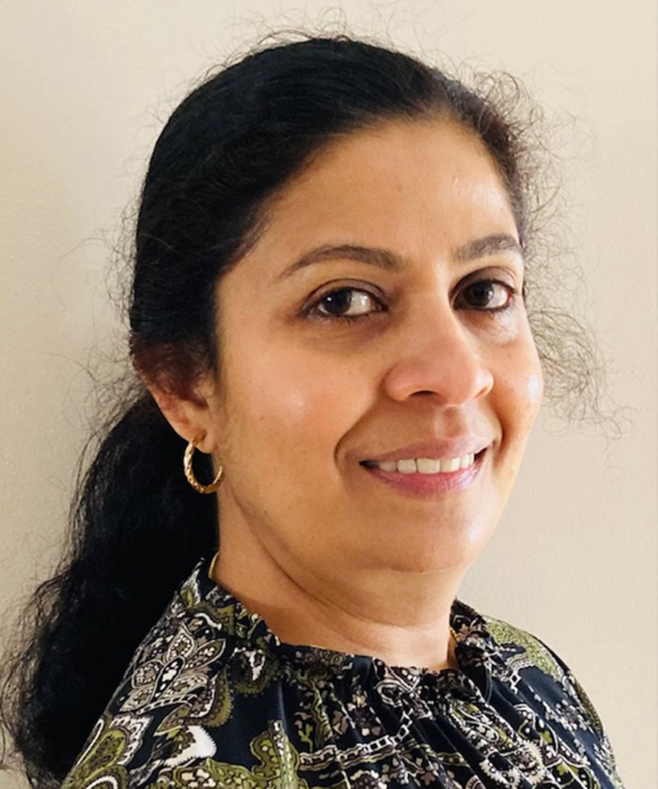
Date: October 8th, 2024, 12:00 – 1:00 pm, ZOOM presentation. Central Time Zone.

Presenter: Dr. Preetha Krishnan, NP, PhD; Nurse Practitioner, Winnipeg Regional Health Authority

Title: Orchestrating Comfort: Getting Everyone on the Same Page: Long Term Care Nurses’ Experiences with Advance Care Planning.

ZOOM LINK: https://ca01web.zoom.us/j/67484190653?pwd=eVBVT1BWUTlsZGdUcFlMZk9SU3JmUT09

Abstract: This presentation highlights the findings of a grounded theory study examining Long Term Care nurses’ experiences with Advanced Care Planning (ACP). The model that emerged from the study demonstrated that nurses’ primary goal in ACP is facilitating conversations aimed at ensuring resident comfort. Achieving this goal involves navigating a complex interplay of individual, interpersonal, organizational, and systemic factors. It was the first Canadian study to illustrate the micro- and macro-perspectives of ACP through the dual lens of Symbolic interactionism and the socio-ecological model. A multitude of implications for the healthcare system and future research arose from this study, specifically with regard to practice, education, research, and policy development.

Upcoming Presentations
Tuesday November 12th, 2024 12:00 – 1:00 pm, Central Time Zone.
Simone Stenekes, RN, MN, CHPCN(C), CNS, Pediatric Palliative Care, WRHA Palliative Care Program: The Impact of COVID-19 Visitor Restrictions on the Multidisciplinary Health Care Team of a Palliative Care Unit: A Qualitative Study.

Tuesday January 14th, 2025 12:00 – 1:00 pm, Central Time Zone.
Cathy Schoales, RN, BEd, IIWCC, PhD, Assistant Professor, School of Nursing, Lakehead University: Being, Becoming and Belonging: The process of social norm formation of nurses working in groups.
ARCHIVE LINK TO ALL RECORDED PRESENTATIONS: https://umanitoba.yuja.com/V/PlayList?node=4121225&a=1926463596&autoplay=1
The Clinical Chair Program, supported by the Health Sciences Centre, University of Manitoba College of Nursing, and the Health Sciences Centre Foundation, aims to foster clinically relevant research partnerships, networks and synergies fueling nursing research and clinical innovation, enhancing knowledge translation, and supporting improved patient outcomes. The goal of this free monthly virtual speaker series is the creation of a space for clinicians, researchers, scholars, and students to share knowledge, expertise, insights, and questions to spark ideas and connection to strengthen nursing research and practice, building a strong nursing community across Manitoba, Saskatchewan, Northwestern Ontario, and beyond!

Dr. Diana E. McMillan, RN, PhD, Professor, Rady Faculty of Health Sciences, College of Nursing, University of Manitoba, & Clinical Chair, Health Sciences Centre.

We are booking presenters for the 2025 series. Please contact Diana at diana.mcmillan@umanitoba.ca if you are interested in sharing your research or innovation.

