Extending a warm welcome to you and your colleagues to join us at the Catalysts for Care 2025 Nursing Grand Rounds Speaker Series!

Date: April 8th, 2025, 12:00 – 1:00 pm, ZOOM presentation. Central Time Zone-DST
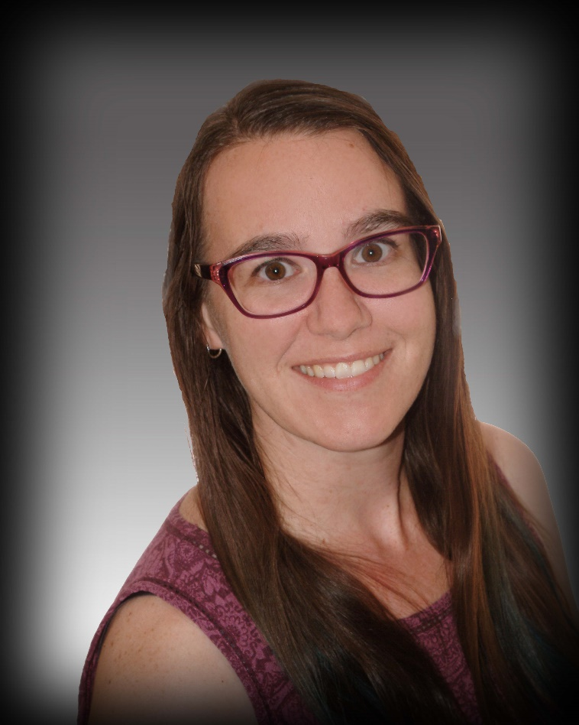

Presenter: Dr. Kathryn Chachula, RN BN MN PhD CCNE
Chair and Associate Professor, Department of Nursing, Faculty of Health Studies, Brandon University, MB.

Title: Supporting the mental health of students and new nursing graduates in Manitoba: Research findings and recommendations.

ZOOM LINK: https://ca01web.zoom.us/j/62193270785?pwd=IqsaCZSB24MLxvDBTlPNf4EmPEJ82Y.1

Abstract:
Students in undergraduate nursing and psychiatric nursing programs are future professionals entering a health care climate rife with violence and anxiety-provoking life-and-death experiences (Chachula & Varley, 2022). Studies conducted with students enrolled in the Bachelor of Nursing and Bachelor of Science in Psychiatric Nursing programs at Brandon University reveal the presence of post-traumatic stress disorder (PTSD) and compassion fatigue (Chachula & Ahmad, 2022). This is further aggravated by student reports of racism, hostility, and incivility with students considering leaving their program of study (Chachula et al., 2022) and 29.4% of young nurses in Manitoba leaving the profession as reported by the Montreal Economic Institute (Faubert, 2024). Findings from quantitative and qualitative research projects that are of significance to nurse educators, student clinical placement sites, and employers of new graduates will be discussed with proposed recommendations to address the related findings. There is a need for nurse educators and employers to develop strategies, policy, and guidelines that attend to PTSD, incivility, and transition-to-practice in the student and new graduate population in Manitoba.

Upcoming Presentations
Tuesday May 13th, 2025 12:00 – 1:00 pm, Central Time Zone.
Susan Alcock, RN, MN, Research Associate, Department of Radiology, Max Rady College of Medicine, University of Manitoba, Winnipeg, MB. Safety and effectiveness of intravenous thrombolysis for acute stroke patients in the Manitoba TeleStroke Program.
https://ca01web.zoom.us/j/63817319765?pwd=IQ8YlOE3UseIo1CLn3sser6cJq9e9k.1
Tuesday June 10th, 2025 12:00 – 1:00 pm, Central Time Zone.
Andrea Toews, RN, MN, CRE, Respiratory Nursing Clinician, St. Boniface Hospital, Winnipeg, MB. The Arduous Passion of Resuscitation Nursing: When the Adrenaline Wears Off.
https://ca01web.zoom.us/j/66417353632?pwd=zgubYW2liwrKdDayhjlFJqWesMUhM3.1
Note: We break for July and August, and restart NGR in September.
ARCHIVE LINK TO ALL RECORDED PRESENTATIONS: https://umanitoba.yuja.com/V/PlayList?node=4121225&a=1926463596&autoplay=1

The Clinical Chair Program, supported by the Health Sciences Centre, University of Manitoba College of Nursing, and the Health Sciences Centre Foundation, aims to foster clinically relevant research partnerships, networks and synergies fueling nursing research and clinical innovation, enhancing knowledge translation, and supporting improved patient outcomes. The goal of this free monthly virtual speaker series is the creation of a space for clinicians, researchers, scholars, and students to share knowledge, expertise, insights, and questions to spark ideas and connection to strengthen nursing research and practice, building a strong clinical nursing research and practice innovation community across Manitoba, and coast to coast to coast!

Dr. Diana E. McMillan, RN, PhD, Professor, Rady Faculty of Health Sciences, College of Nursing, University of Manitoba, & Clinical Chair, Health Sciences Centre.
We are booking presenters for the 2026 series. Please contact Diana at diana.mcmillan@umanitoba.ca if you are interested in sharing your research or innovation.

