Extending a warm welcome to you and your colleagues to join us at the Catalysts for Care 2025 Nursing Grand Rounds Speaker Series!
Date: June 10th, 2025, 12:00 – 1:00 pm, ZOOM presentation. Central Time Zone-DST
Presenter: Andrea Toews, RN, MN, CRE, Respiratory Nursing Clinician, St. Boniface Hospital, Winnipeg, MB.

Title: The Arduous Passion of Resuscitation Nursing: When the Adrenaline Wears Off.

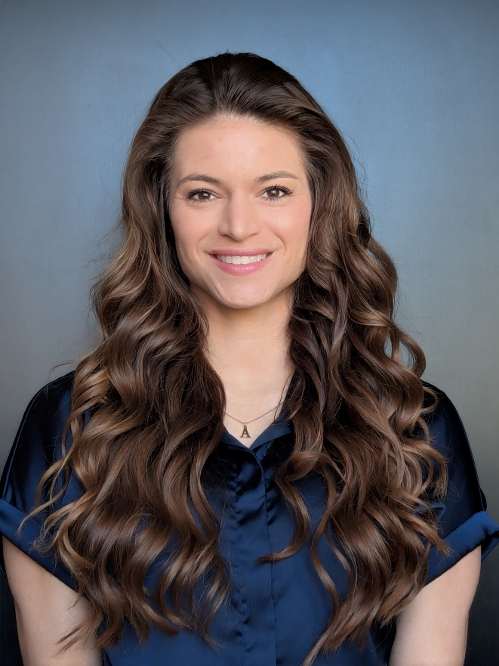
ZOOM LINK: https://ca01web.zoom.us/j/66417353632?pwd=zgubYW2liwrKdDayhjlFJqWesMUhM3.1

Abstract:
A qualitative study was conducted to explore emergency room (ER) nurses’ experiences of in-hospital resuscitation events and their experiences of clinical event debriefing. Emergency nurses from an urban tertiary hospital located in Western Canada were interviewed on their experiences. Four themes were identified: (1) ER nurses’ experiences of resuscitation – ‘The adrenaline rush,’ (2) ER nurses’ experiences post-resuscitation – ‘When the adrenaline wears off’, (3) ER nurses’ perspectives of clinical event debriefing, and (4) ER nurses’ recommendations for future practice and resources. Participants described negative psychological consequences resulting from providing resuscitation care, which had profound effects on their personal and professional lives. Participants identified gaps in supportive measures related to providing resuscitation care. Benefits, barriers, facilitators, and recommendations for clinical event debriefing, along with other recommendations for future practice, were identified. Implementing supportive measures for those providing resuscitation care is required for nurse’s well-being, and in the best interest of the patients, families, and the healthcare organization.

Upcoming Presentations

Tuesday September 9th, 2025 12:00 – 1:00 pm, Central Time Zone.
Lisa Knisley, RN, PhD, Assistant Professor, College of Nursing, University of Manitoba, Winnipeg, MB; Research Scientist, Children’s Hospital Research Institute of Manitoba; Co-Director, Translating Emergency Knowledge for Kids (TREKK); Co-Lead, Research into the Enhancement of Acute Care for Children’s Health (REACH). Translating Emergency Knowledge for KIDS (TREKK): The key roles of nurses in sharing the latest evidence in pediatric emergency care across Canada.
https://ca01web.zoom.us/j/63749408879?pwd=KKOaChATuQaM9J5SIzkjXlyzaqs0VJ.1
Tuesday October 14th, 2025 12:00 – 1:00 pm, Central Time Zone.
Kim Mitchell, RN, PhD, Assistant Professor, & Marnie Kramer, RN, PhD, Assistant Professor, College of Nursing, University of Manitoba, Winnipeg, MB. An exploratory study of threshold concepts in nursing education: Examining student and faculty perspectives about the troublesome nature of learning concepts of heath and illness.
https://ca01web.zoom.us/j/68777905586?pwd=V3t56aaaFMxhnSvTQa4KHsdxX3RXO7.1
Tuesday November 18th, 2025 12:00 – 1:00 pm, Central Time Zone.
Edward Cruz, RN, PhD, CCN, FCAN, Assistant Professor & Associate Dean Undergraduate Programs, College of Nursing, University of Windsor, Windsor, ON. Presentation title: TBC
https://ca01web.zoom.us/j/63017221594?pwd=87NpThWSRhyGBvMeNM59dFVttKIYgw.1
ARCHIVE LINK TO ALL RECORDED PRESENTATIONS: https://umanitoba.yuja.com/V/PlayList?node=4121225&a=1926463596&autoplay=1

The Clinical Chair Program, supported by the Health Sciences Centre, University of Manitoba College of Nursing, and the Health Sciences Centre Foundation, aims to foster clinically relevant research partnerships, networks and synergies fueling nursing research and clinical innovation, enhancing knowledge translation, and supporting improved patient outcomes. The goal of this free monthly virtual speaker series is the creation of a space for clinicians, researchers, scholars, and students to share knowledge, expertise, insights, and questions to spark ideas and connection to strengthen nursing research and practice, building a strong clinical nursing research and practice innovation community across Manitoba, and coast to coast to coast!

Dr. Diana E. McMillan, RN, PhD, Professor, Rady Faculty of Health Sciences, College of Nursing, University of Manitoba, & Clinical Chair, Health Sciences Centre.

We are booking presenters for the 2026 series. Please contact Diana at diana.mcmillan@umanitoba.ca if you are interested in sharing your research or innovation.

