Extending a warm welcome to you and your colleagues to join us at the Catalysts for Care 2026 Nursing Grand Rounds Speaker Series!

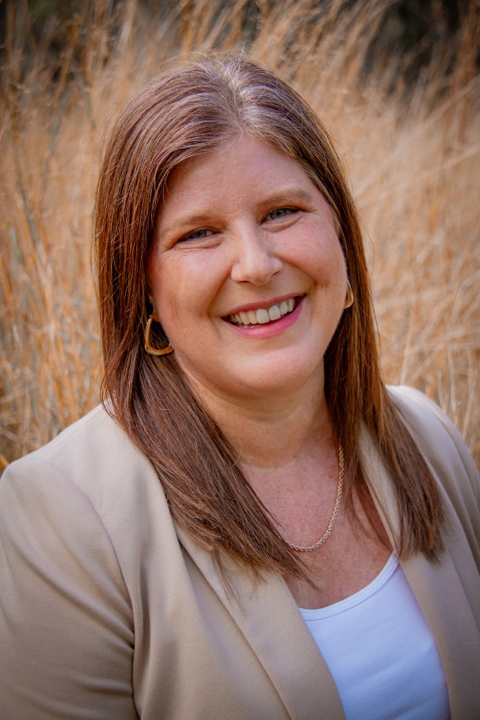
Date: March 10th, 2026, 12:00 – 1:00 pm, ZOOM presentation. Central Time Zone-Standard Time
Presenter: Dr. Genevieve Thompson, RN, PhD, CHPCN(c), Professor and Associate Dean, Graduate Program, College of Nursing, University of Manitoba, MB; Research Chair, Person Directed Living

Title: Research for Change in Long-Term Care Settings.

ZOOM LINK: https://ca01web.zoom.us/j/61384241888?pwd=5Fe1Vxjf3d4ZyxVVzHgtiUOoCGADYP.1

Abstract:

Conducting research in residential long-term care settings, also known as nursing homes or personal care homes, can pose significant opportunities and challenges. Drawing on over 18 years of experience in conducting research in this unique setting, this presentation will explore what some of the barriers and facilitators to conducting research in nursing homes have been. Specifically, I will draw on the Strengthening a Palliative Approach in Long-Term Care (SPA-LTC) national study as well my current work with Riverview Health Centre in developing an institutional evaluation of their new model of care: person directed living. Through exemplars, I will highlight key learnings, relevant findings, and recommendations for future research in this care setting.

UPCOMING PRESENTATIONS

Tuesday April 14th, 2026 12:00 – 1:00 pm, Central Time Zone, ***Daylight saving time
Josie D. Bolianatz, RN, MN. Lead, Clinical. Ontario Health
Becoming a Nurse: Pedagogical Care and Professional Formation in Nursing Education.
https://ca01web.zoom.us/j/67075400127?pwd=KmEp7gAlT280fpW2qARqiaXaG5qCJK.1

Tuesday May 12th, 2026 9:00 – 10:00 am, Central Time Zone. (Nursing Week)
Dr. Greta G. Cummings, RN, PhD, FCAHS, FAAN, FCAN, Professor & Principal, CLEAR Outcomes (Connecting Leadership, Education & Research) Outcomes Program, Faculty of Nursing, University of Alberta. From Insight to Impact: Advancing Nursing’s Future Through Research.
https://ca01web.zoom.us/j/65917807310?pwd=JUzYIQvm7tGgZu5IEbZqT9IXpQeqz9.1
Meeting ID: 659 1780 7310
Passcode: 446011

INVITATION TO PARTICIPATE – Your feedback is welcome!
We are conducting a brief study of participants’ perceptions of Nursing Grand Rounds, please
click here for more information and to participate: https://clinicalnursingchair.ca/catalysts-for-care-nursing-grand-rounds/

ARCHIVE LINK TO ALL RECORDED PRESENTATIONS: https://umanitoba.yuja.com/V/PlayList?node=4121225&a=1926463596&autoplay=1

The Clinical Chair Program, supported by the Health Sciences Centre, University of Manitoba College of Nursing, and the Health Sciences Centre Foundation, aims to foster clinically relevant research partnerships, networks and synergies fueling nursing research and clinical innovation, enhancing knowledge translation, and supporting improved patient outcomes. The goal of this free monthly virtual speaker series is the creation of a space for clinicians, researchers, scholars, and students to share knowledge, expertise, insights, and questions to spark ideas and connection to strengthen nursing research and practice, building a strong clinical nursing research and practice innovation community across Manitoba, and coast to coast to coast!

Dr. Diana E. McMillan, RN, PhD, Professor, Rady Faculty of Health Sciences, College of Nursing, University of Manitoba, & Clinical Chair, Health Sciences Centre.

We will soon begin booking presenters for the 2027 series. Please contact Diana at diana.mcmillan@umanitoba.ca if you are interested in sharing your research or innovation.

