Extending a warm welcome to you and your colleagues to join us at the Catalysts for Care 2025 Nursing Grand Rounds Speaker Series!

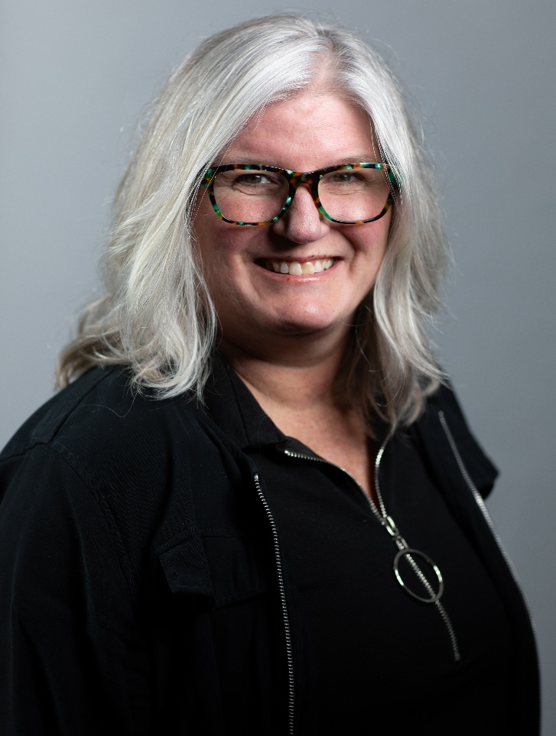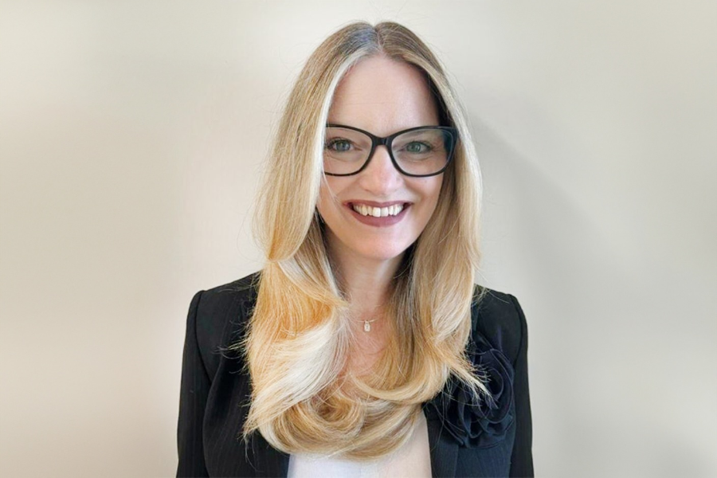

Date: October 14th, 2025, 12:00 – 1:00 pm, ZOOM presentation. Central Time Zone-DST
Presenters: Dr. Kim Mitchell, RN, PhD, Assistant Professor, & Dr. Marnie Kramer, RN, PhD, Assistant Professor, College of Nursing, University of Manitoba, Winnipeg, MB.

Title: An exploratory study of threshold concepts in nursing education: Examining student and faculty perspectives about the troublesome nature of learning concepts of heath and illness.

ZOOM LINK: https://ca01web.zoom.us/j/68777905586?pwd=V3t56aaaFMxhnSvTQa4KHsdxX3RXO7.1
Abstract: An exploratory study of threshold concepts in nursing education: Examining student and faculty perspectives about the troublesome nature of learning concepts of heath and illness

Background: The goal of conceptual teaching is to foster an understanding of nursing content through concepts. The University of Manitoba Bachelor of Nursing Program implemented a concept-based curriculum in 2016. The effectiveness of conceptual learning, especially in cornerstone courses such as pathophysiology, pharmacology, and health assessment has not been studied. We propose a study using threshold concept theory to identify the threshold concepts of three leveled courses in the Bachelor of Nursing program (NURS2500, 2514, 3512) to understand how concepts in these courses act as portals to professional nursing identity development.
Methods: Using a qualitative and quantitative triangulated design we surveyed 300 students and interviewed ten faculty about the troublesome nature of learning concepts in these courses. “Troublesome” means more than struggles with course content and can also include course material that is unsettling, awe inspiring, startling, surprising, or evokes curiosity.
Findings: We identified 22 threshold concepts across the three courses from the student data. After layering in the faculty interview data, we identified four overarching concepts: Prioritization, Integrating Pharmacology, Language and Literacy, and Ongoing Assessment. The threshold concepts point to the integrative nature of the material in these courses.
Conclusions: Threshold concepts have only been sparsely identified in the nursing profession. This presentation will detail the four threshold concepts identified and discuss how they meet the criteria for threshold concept status. Identifying threshold concepts for curriculum development could revolutionize concept-based curricular thinking.

Upcoming Presentation

Tuesday November 18th, 2025 12:00 – 1:00 pm, Central Time Zone.
Edward Cruz, RN, PhD, CCN, FCAN, Associate Professor & Associate Dean Undergraduate Programs, College of Nursing, University of Windsor, Windsor, ON; Co-author: Kristoffer Romero, CPsych, PhD, Assistant Professor, Department of Psychology, University of Windsor. Filipino Nurses’ Employment Experiences in Ontario, Canada.
https://ca01web.zoom.us/j/63017221594?pwd=87NpThWSRhyGBvMeNM59dFVttKIYgw.1

Please note we pause in December to celebrate the season and will resume on Tuesday January 13th, 2026.

ARCHIVE LINK TO ALL RECORDED PRESENTATIONS: https://umanitoba.yuja.com/V/PlayList?node=4121225&a=1926463596&autoplay=1

The Clinical Chair Program, supported by the Health Sciences Centre, University of Manitoba College of Nursing, and the Health Sciences Centre Foundation, aims to foster clinically relevant research partnerships, networks and synergies fueling nursing research and clinical innovation, enhancing knowledge translation, and supporting improved patient outcomes. The goal of this free monthly virtual speaker series is the creation of a space for clinicians, researchers, scholars, and students to share knowledge, expertise, insights, and questions to spark ideas and connection to strengthen nursing research and practice, building a strong clinical nursing research and practice innovation community across Manitoba, and coast to coast to coast!

Dr. Diana E. McMillan, RN, PhD, Professor, Rady Faculty of Health Sciences, College of Nursing, University of Manitoba, & Clinical Chair, Health Sciences Centre.

We are booking presenters for the 2026 series. Please contact Diana at diana.mcmillan@umanitoba.ca if you are interested in sharing your research or innovation.

