Extending a warm welcome to you and your colleagues to join us at the Catalysts for Care 2025 Nursing Grand Rounds Speaker Series!

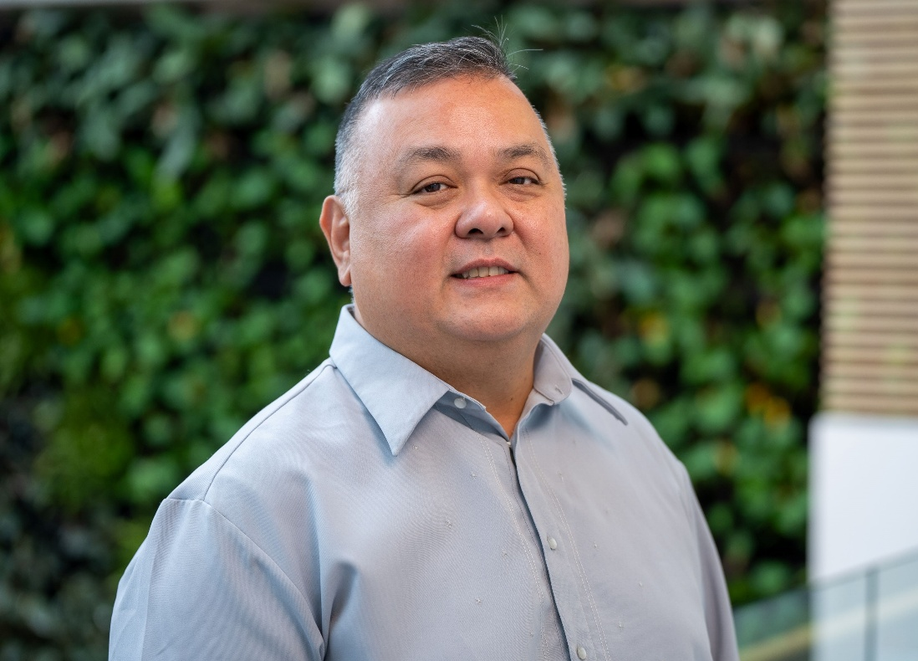
Date: November 18th, 2025, 12:00 – 1:00 pm, ZOOM presentation. Central Time Zone-Standard Time (NB: Regular date revised due to Remembrance Day)
Dr. Edward Cruz, RN, PhD, CCN, FCAN, Associate Professor & Associate Dean Undergraduate Programs, College of Nursing, University of Windsor, Windsor, ON; Co-author: Kristoffer Romero, CPsych, PhD, Assistant Professor, Department of Psychology, University of Windsor. Filipino Nurses’ Employment Experiences in Ontario, Canada.

Zoom Link:
https://ca01web.zoom.us/j/63017221594?pwd=87NpThWSRhyGBvMeNM59dFVttKIYgw.1

Abstract:
This presentation is based on the findings of our mixed-methods study that compared employment experiences of Philippine-educated nurses (PENs) and Canadian-educated Filipino nurses in Ontario. Using a provincial survey (n=510) and interviews (n=50), researchers found that PENs were significantly more likely to work in lower-tier positions and experience workplace microaggressions. Both groups faced discrimination and workplace transition challenges, but Canadian-educated Filipino nurses had better career advancement opportunities and access to support networks. The findings highlight that while both groups encounter barriers, PENs face additional systemic challenges affecting their career progression, necessitating targeted interventions like mentorship programs and increased Filipino representation in leadership roles.

Please note we pause in December to celebrate the season and will resume on Tuesday January 13th, 2026.

UPCOMING PRESENTATIONS
January 13, 2026 12:00 – 1:00 pm, Central Time Zone.
Rebecca Cameron, RN, MN, Instructor, RRC Polytech; PhD Student, College of Nursing, University of Manitoba. Creating Safe Spaces: Indigenous Cultural Safety in Health Care — From Awareness to Action. https://ca01web.zoom.us/j/68646396624?pwd=Eb1WjCjF9r2R9M6ai307LtIo4gbhaa.1

Tuesday February 10th, 2026 12:00 – 1:00 pm, Central Time Zone.
Karen Burgess, RPN, MPN, BScPN, BA, CNS, CISM Clinical Lead, Health Sciences Centre, Winnipeg, MB. Frequency and impact of potentially traumatic events on hospital security personnel.
https://ca01web.zoom.us/j/61088144803?pwd=O3OecCzEaaSxM5UiLhGtVAjW7rGuAT.1

Tuesday March 10th, 2026 12:00 – 1:00 pm, Central Time Zone.
Dr. Genevieve Thompson, RN, PhD, Professor and Associate Dean, Graduate Program, College of Nursing, University of Manitoba, MB. Title: TBC
https://ca01web.zoom.us/j/61384241888?pwd=5Fe1Vxjf3d4ZyxVVzHgtiUOoCGADYP.1

ARCHIVE LINK TO ALL RECORDED PRESENTATIONS: https://umanitoba.yuja.com/V/PlayList?node=4121225&a=1926463596&autoplay=1

The Clinical Chair Program, supported by the Health Sciences Centre, University of Manitoba College of Nursing, and the Health Sciences Centre Foundation, aims to foster clinically relevant research partnerships, networks and synergies fueling nursing research and clinical innovation, enhancing knowledge translation, and supporting improved patient outcomes. The goal of this free monthly virtual speaker series is the creation of a space for clinicians, researchers, scholars, and students to share knowledge, expertise, insights, and questions to spark ideas and connection to strengthen nursing research and practice, building a strong clinical nursing research and practice innovation community across Manitoba, and coast to coast to coast!

Dr. Diana E. McMillan, RN, PhD, Professor, Rady Faculty of Health Sciences, College of Nursing, University of Manitoba, & Clinical Chair, Health Sciences Centre.

We are booking presenters for the 2026 series. Please contact Diana at diana.mcmillan@umanitoba.ca if you are interested in sharing your research or innovation.

