Extending a warm welcome to you and your colleagues to join us at the Catalysts for Care 2026 Nursing Grand Rounds Speaker Series!

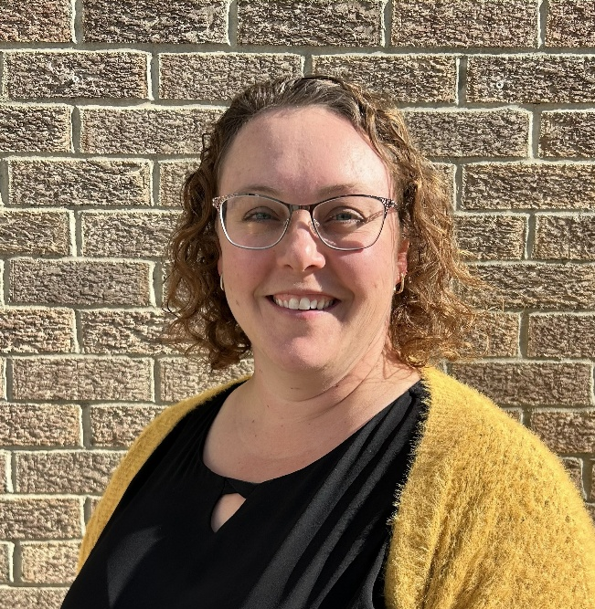
Date: June 9th 2026, 12:00 – 1:00 pm, ZOOM presentation
Presenter: Lyndsay Russell, RN, BN, CNE, Unit 22-Cardiology/CCU, Alberta Health Services, Red Deer, AB.

Title: Investing in staff thru unit focused education.

ZOOM LINK: https://ca01web.zoom.us/j/62382685798?pwd=BLUFODaMxMxrF0NJUWs54eG9y8VV8b.1
Meeting ID: 623 8268 5798
Passcode: 742483

ABSTRACT:
Clinical nurse educators are often focused on preparing new staff for their role within the unit. The time commitment for designing and implementing new hire orientation is significant, resulting in limited time and resources for ongoing educational opportunities for existing staff.

Recognizing the effect that limited educational opportunities had on staff engagement and unit culture within our ED, the CNEs moved towards a unit focused approach during the 2024 year. With the goal of investing in staff development across all phases we focused on the following three principles: flexibility, relevance, and engagement.

By shifting our educational goals, the education team was able to introduce innovative learning opportunities tailored to the needs of the unit and its staff. These opportunities had a profound impact on the staff, influencing staff retention, patient care, and shifting the unit culture.

UPCOMING PRESENTATIONS (We pause in July & August)
Tuesday September 8th, 2026 12:00 – 1:00 pm, Central Time Zone.
Dr. Leah Lambert, PhD, RN, Senior Scientist, Nursing Research, Department of Clinical Research, BC Cancer Research Institute & Clinical Associate Professor, UBC School of Nursing; &
Dr. Sandra Lauck, PhD, RN, FCAN FAAN FESC, St. Paul's Hospital Professorship in Cardiovascular Nursing at UBC, Associate Professor, Knowledge Exchange & Mobilization Scholar, UBC Clinician Scientist, &
Senior Clinical Nurse Specialist Lead, St. Paul's Hospital, Vancouver BC.
Title: Building a Sustainable Clinical Nurse Specialist Workforce: Evidence, Policy, and Implementation Lessons from British Columbia. https://ca01web.zoom.us/j/67469636246?pwd=fP8LBMtPIQ9Uozrzh5etcRjFU66VWM.1

Tuesday October 13th, 2026 12:00 – 1:00 pm, Central Time Zone.
Dr. Heidi Fan, RN, PhD, Assistant Professor, College of Nursing, University of Manitoba, Winnipeg, MB
Topic: Perceptions of Virtual Breastfeeding Support
https://ca01web.zoom.us/j/65029600459?pwd=2xJ6HTYTrpvt4g7qiF1bAUbTYeQ8gq.1

Tuesday November 10th, 2026 12:00 – 1:00 pm, Central Time Zone.
Kurt Schwarz, MDiv, Spiritual Health Practitioner, Spiritual Health Dept, Health Sciences Centre (HSC), Winnipeg, MB; Melody Newcomb, MA, CCC, MTA, Music and Expressive Arts Therapist and Consultant, HSC, Winnipeg, MB; & Dr. Kendra Rieger, RN, PhD, Associate Professor and Health Research BC Scholar, Trinity Western University School of Nursing, Langley, BC. Title: Making Meaningful Connections through Arts-based Spiritual Care: An Interdisciplinary, Cooperative Investigation.
https://ca01web.zoom.us/j/61631047674?pwd=pZxBZBJfSpifbojtrTUNexD2HsOaRJ.1

Final Call - INVITATION TO PARTICIPATE – Your feedback is welcome!
We are conducting a brief study of participants’ perceptions of Nursing Grand Rounds, please
click here for more information and to participate: https://clinicalnursingchair.ca/catalysts-for-care-nursing-grand-rounds/

ARCHIVE LINK TO ALL RECORDED PRESENTATIONS: https://umanitoba.yuja.com/V/PlayList?node=4121225&a=1926463596&autoplay=1

The Clinical Chair Program, supported by the Health Sciences Centre, University of Manitoba College of Nursing, and the Health Sciences Centre Foundation, aims to foster clinically relevant research partnerships, networks and synergies fueling nursing research and clinical innovation, enhancing knowledge translation, and supporting improved patient outcomes. The goal of this free monthly virtual speaker series is the creation of a space for clinicians, researchers, scholars, and students to share knowledge, expertise, insights, and questions to spark ideas and connection to strengthen nursing research and practice, building a strong clinical nursing research and practice innovation community across Manitoba, and coast to coast to coast!

Dr. Diana E. McMillan, RN, PhD, Professor, Rady Faculty of Health Sciences, College of Nursing, University of Manitoba, & Clinical Chair, Health Sciences Centre.

We will soon begin booking presenters for the 2027 series. Please contact Diana at diana.mcmillan@umanitoba.ca if you are interested in sharing your research or innovation.

