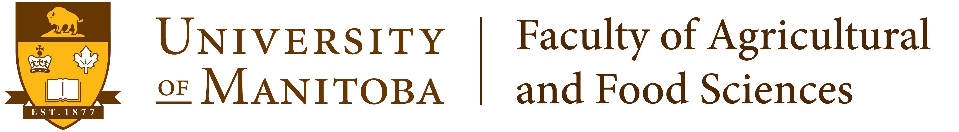

“The Department of Plant Science:
What prospects for a brighter future?”

Presented by:

Dr. Fouad Daayf,
Candidate for the position
of Plant Science Department Head

Thursday, October 16, 2014

Carolyn Sifton Lecture Theatre
130 Agriculture Building

3:30 - 4:30 pm
Refreshments at 3:00 pm in the Atrium

All are welcome!

