 **University of Guelph Plant Science Symposium**

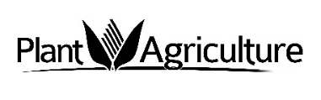**Communication in Agriculture**

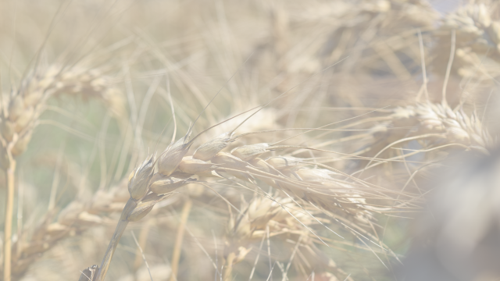 **Part of the DuPont Pioneer Plant Science Symposium Series**

**Monday, November 14, 2016**

**OAC Centennial Arboretum Center**

**Free Registration**

**Can’t Attend? Join us via Webinar!**

**Register NOW at:** [www.plant.uoguelph.ca/PS-Symposium](http://www.plant.uoguelph.ca/PS-Symposium)

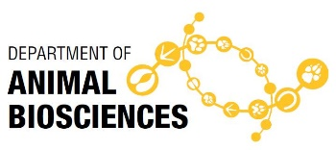

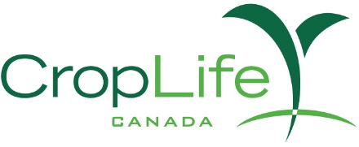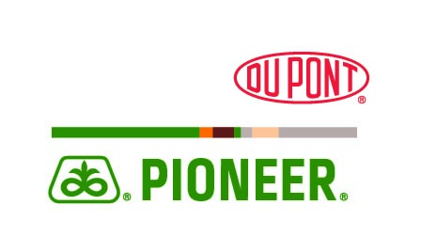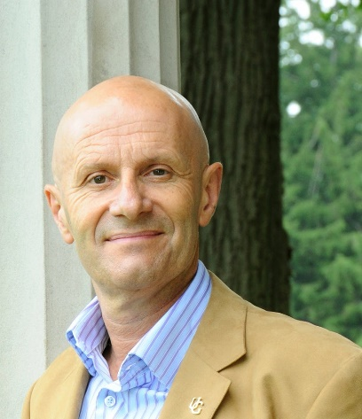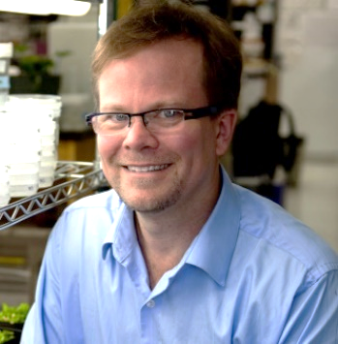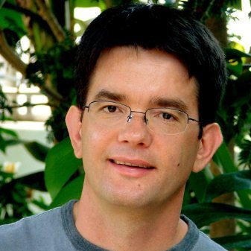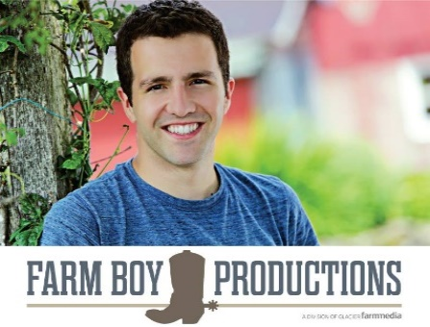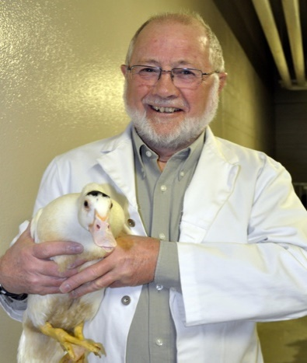Funding for this Event Provided by:

Alastair Summerlee

Jen Christie

Ian Duncan

Radu Totir

Kevin Folta

Bruce Sargent



