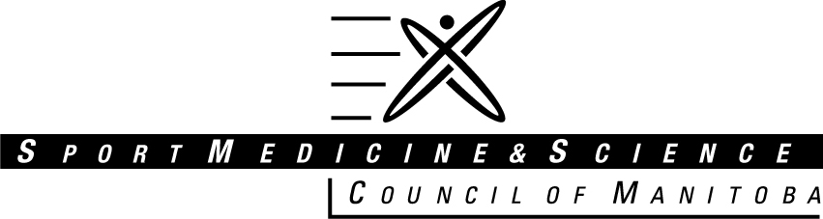

GRADUATE SCHOLARSHIP

A scholarship fund has been established by the Sport Medicine & Science Council of Manitoba to offer financial support and encourage innovative and relevant research projects that reflect the objectives and goals of the Council. The Sport Medicine & Science Council of Manitoba offers scientific support and sport medicine services to enhance the training of Manitoba athletes and recreational participants at all levels. The Council strives to encourage students to be creative investigators in the academic setting.

The Sport Medicine & Science Council of Manitoba offers to provide an annual award of $500.00 to promote the achievements and help further the education of our student member groups. The award will be presented to a suitable candidate at the SMSCM Annual General Meeting by the President of the Sport Medicine & Science Council of Manitoba.

The Sport Medicine & Science Council of Manitoba Executive Committee will select the student whom:

1. Has achieved a cumulative Grade Point Average of at least 3.5, has been enrolled and completed 1 full-time year of study at the Masters level, or two years of part time study deemed equivalent to the 1 full-time year.
2. Shows outstanding volunteer work related to sport medicine; has demonstrated a commitment to positively influencing sport participation in Manitoba athletes and the general sporting public.
3. Displays an impressive extracurricular background related to sport medicine;
4. Has involvement in research related experience congruent with the objectives and goals of the Sport Medicine Council of Manitoba.

**Tenable at**: This award is primarily intended for students enrolled in a University in the province of Manitoba. Special consideration may be given to an exceptional candidate registered in a Canadian university outside of Manitoba.

Students cannot win this scholarship in two consecutive years. Students should fill out this scholarship application and submit with a copy of their transcripts. The application is to be sent to the Sport Medicine & Science Council of Manitoba office and the Selection Committee will select a winner.

### SPORT MEDICINE & SCIENCE COUNCIL OF MANITOBA

145 Pacific Ave

Winnipeg, MB R3B 2Z6

(204) 925-5750

Fax: (204) 925-5624

e-mail: sport.med@sportmanitoba.ca

**\*\*\*APPLICATION DEADLINE IS MAY 10, 2019\*\*\***

**Note: The transcripts for the 2019 spring semester may not be available by this time. Please send the latest copy of your transcript that is available.**

#### SPORT MEDICINE & SCIENCE COUNCIL OF MANITOBA

**2019 GRADUATE SCHOLARSHIP APPLICATION**

1. Name:

Address:

City: Province: Postal Code:

Telephone Number:

Education Institution currently attending:

Field of Interest: (please check appropriate selection)

Athletic Therapy Medicine

Biomechanics Nutrition

Chiropractic Physiotherapy

Dentistry Sport Psychology

Exercise Physiology Nursing

1. Please list three references whom we may contact:
2. Name:

Relation:

Time Known For:

Telephone Number:

1. Name:

Relation:

Time Known For:

Telephone Number:

1. Name:

Relation:

Time Known For:

Telephone Number:

1. Minimum G.P.A. of 3.5 or equivalent – Please attach most recent transcripts or most recent marks statement.
2. Volunteer activity related to Sport Medicine. In the space below please list your activities in the last two years. (Please identify if volunteer activity was part of a practicum) – No attachments

E. Volunteer activity. In the space below please list your volunteer activities in the last two years. – No attachments

1. Other activities related to Sport Medicine. In the space provided below please list your activities in the last two years. Activities can include but are not limited to: research, special projects, presentation, awards & leadership. - No attachments

1. Personal Involvement in sport and/or active living. In the space provided below please describe your activities in the last two years. -No attachments

1. Future activities related to Sport Medicine. In the space below please describe your future ambitions as they relate to Sport Medicine. – No attachments

1. Number of years in present academic program.

______

###### 

Please attach application and transcript and send to:

##### Sport Medicine & Science Council of Manitoba

145 Pacific Avenue

Winnipeg, MB R3B 2Z6

(204) 925-5750

Fax: (204) 925-5624

E-mail: sport.med@sportmanitoba.ca

**\*\*\*APPLICATION DEADLINE IS MAY 10, 2019**