**Do you have excess body fat?**

**Why not try a weight loss study looking at the effects of whey protein and pea protein on**

**body composition?**

**You may be eligible if you:**

1. Are between the ages of 30 and 50;
2. Have above normal body weight for height (excess body fat);
3. Are **not** diagnosed with a chronic disease.

*Volunteers will be compensated for their participation.*

For more information call: **204-258-1207** or email: **studyinfo@sbrc.ca**



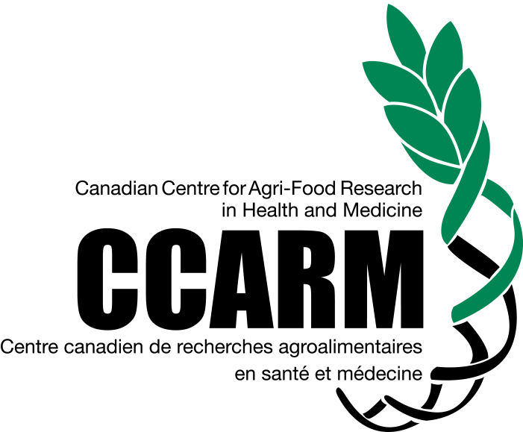

Newspaper Ad #2, Version 1.1, April 5, 2019