Example of Best Practices from Other Post-Secondary Institutions  McMaster University: http://accessibility.mcmaster.ca/  Queens University: http://www.queensu.ca/accessibility/across-campus/queens-accessibility-initiatives  Ryerson University: http://www.ryerson.ca/accessibility/  University of Ottawa: http://www.uottawa.ca/respect/accessibility-hub/  Western University: http://accessibility.uwo.ca/  York University: http://accessibilityhub.info.yorku.ca/  Other Useful Resources  UofM Accessibility Resource Webpage: http://umanitoba.ca/student/saa/accessibility/resources-for-online-accessibility.html  UofM Feedback Webpage: http://umanitoba.ca/admin/vp_admin/ofp/ohrcm/AMA.html  Accessibility for Manitobans Act Webpage: http://www.accessibilitymb.ca/accessibility-standards.html  AMA Plan guide PDF: http://www.accessibilitymb.ca/pdf/accessibility-plan.pdf  Disability Issues Office Webpage: http://www.gov.mb.ca/dio/ |  | Important Dates  Unit Audits Due: October 14, 2016  University Accessibility Plan Due: December 2016  Accessibility Compliance for the Customer Service Standard: November 1, 2017  Accessibility Plan Updates: Every 2 Years |  | Unit Accessibility Audit  - Due: Oct. 14 2016

Useful Contacts

Jackie Gruber, Human Rights and Conflict Management Officer
Jackie.Gruber@umanitoba.ca

Krystyl Bergen, Accessibility Coordinator
Krystyl.Bergen@umanitoba.ca

Laksh Khatter, Change Management Consultant
Laksh.Khatter@umanitoba.ca

Jeff Buhse, Assistive Technologist
Jeff.Buhse@umanitoba.ca

r
Accessibility Terminology  Accessibility:  Related to the AMA legislation, accessibility means giving people of all abilities opportunities to participate fully in everyday life. Accessibility refers to the ability to access and benefit from a system, service, product or environment.  Accommodation:  Arrangements made to allow persons with disabilities to participate or benefit equally. There is no set formula for accommodating people with disabilities; the person involved must be consulted.  Alt Tags:  Also referred to as alt attributes, alt tags provide a verbal description of a visual or graph for individuals with visual impairments who use screen readers.  Barriers:  Related to the AMA legislation- obstacles that limit access and prevent people with disabilities from fully participating in society. Most barriers are not intentional. Barriers usually arise because the needs of people with disabilities are not considered from the beginning.  Built Environment:  More than buildings, the built environment includes everything humans have changes in the natural environment, such as sidewalks, curbs, roadways, and parks. |  | Disability:  A disability is a condition that limits a person`s daily activities. Persons with disabilities may have a long-term physical, mental, intellectual or sensory impairments which, in interaction with various barriers, may hinder their participation on an equal basis with others. A disability, aging, an injury and other life events may temporarily or permanently affect mobility, dexterity, vision, hearing, communication understanding or mental health.  Duty to Reasonably Accommodate:  The requirement established by The Human Rights Code (Manitoba) to remove barriers up to the point of undue hardship.  Persons Disabled by Barriers:  Individuals with a physical or mental impairment prevented from full participation by a factor in the environment.  Reasonable Accommodation:  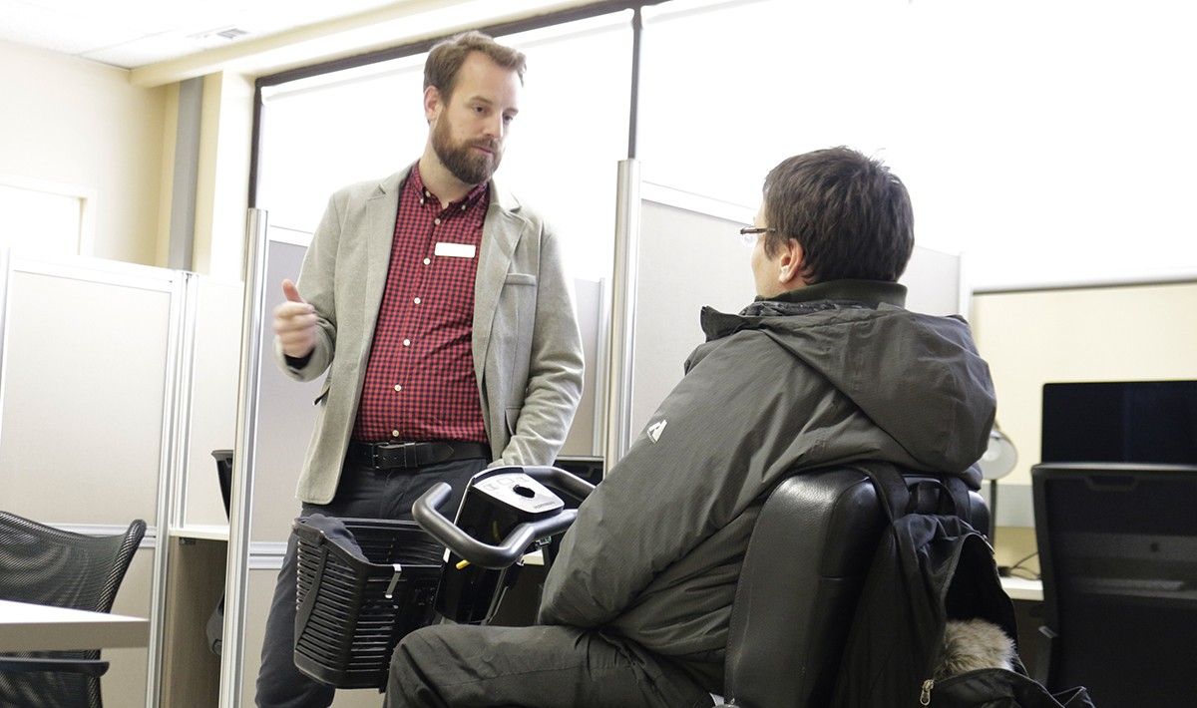  A wide range of modification or adjustments to meet the needs of persons in a respectful manner. Usually simple and inexpensive, reasonable accommodations consider the needs of persons or groups who have characteristics protected under The Human Rights Code (Manitoba), such as a disability. |  | Breaking down Barriers  Attitudinal Barriers:  When people think and act based on false assumptions. Example: thinking people who cannot communicate verbally have nothing to say.  Information and Communicational Barriers:  When information is offered in a form that suits some but not all of the population. Example: Signs that are small or visually confusing.  Technological Barriers:  Focusing on information and service delivery on technology that is not accessible for all. Example: a website that cannot be used by people who are blind or visually impaired through a screen-reader.  Systemic Barriers:  Policies, practices or procedures that result in some people receiving unequal access or being excluded. Example: eligibility criteria that effectively exclude people based on a disability.  Physical and Architectural Barriers:  When the environment presents challenges that make it difficult for some to easily access a place. Example: classroom aisles that are too narrow for a person with a walker or wheelchair.

