Expert Roundtable on Canadian Economic Sanctions
Oct 9, 2019
8:30am – 4:30pm
Museum of Nature, Ottawa ON

Introduction

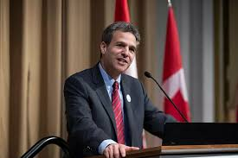
Roland Paris is Professor of International Affairs at the Graduate School of Public and International Affairs at the University of Ottawa, Associate Fellow of the Royal Institute of International Affairs (Chatham House) and a member of the World Economic Forum's Global Future Council on Geopolitics.
Previously, he was Senior Advisor on Global Affairs and Defence to the Prime Minister of Canada, founding Director of the Centre for International Policy Studies at the University of Ottawa, Director of Research at the Conference Board of Canada, Assistant Professor of Political Science and International Affairs at the University of Colorado at Boulder, Visiting Researcher at the Johns Hopkins School of Advanced International Studies in Washington, DC, Visiting Fellow at the Institut d'études politiques (Sciences Po) in Paris, and Global Ethics Fellow at the Carnegie Council for Ethics in International Affairs. He has also worked as a policy advisor in Canada’s Department of Foreign Affairs and in the Privy Council (Cabinet) Office, and was appointed to a ten-member group of international experts advising the Secretary General of the North Atlantic Treaty Organization.

Panel 1: Canada’s use of sanctions to date

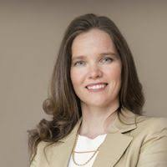
Meredith Lilly is Associate Professor at Carleton University where she holds the Simon Reisman Chair in International Affairs. She has served as international trade adviser to former Prime Minister Stephen Harper and worked within the Prime Minister’s Office to oversee the conclusion of Canada’s free-trade negotiations with the EU, South Korea, and the Trans-Pacific Partnership. Dr. Lilly’s current research centres on international labour mobility and Canada-US relations.

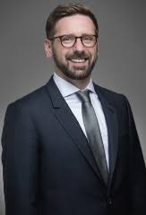
Michael Nesbitt is a senior fellow at the University of Calgary. Before joining the Faculty of Law he practiced law and worked in the areas of Middle East policy, human rights, international sanctions and terrorism for Canada’s Department of Foreign Affairs. He has also worked internationally for the United Nations’ International Criminal Tribunal for the Former Yugoslavia in the Appeals Chamber.

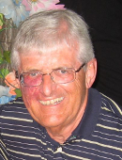
Gerry Ferguson is a Distinguished Professor in the Faculty of Law at the University of Victoria. His teaching and scholarly interests centre on criminal law, criminal procedure, sentencing, global corruption, and mental health law. He is currently a Senior Associate of the International Centre for Criminal Law and a Member of a United Nations Expert group working on Anti-Corruption Academic materials. He is a former member of the National Advisory Council of the Law Commission of Canada and author of Global Corruption: Law, Theory & Practice (2018) available free of charge at https://icclr.org/publications/global-corruption-law-theory-and-practice/”

Panel 2: Canadian machinery and process

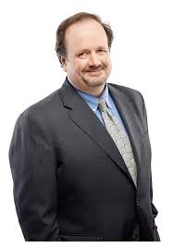

John Boscariol is a lawyer and partner with McCarthy Tetrault where he is also the head of the firm’s International Trade & Investment Law Group. His practice focuses on international trade and investment protection agreements, including export and import controls, economic sanctions, blocking measures, and defence trade. John is an adjunct professor at the University of Western Ontario law school and has testified before the Canadian Parliament on the enforcement of economic sanctions and anti-terrorism laws.

Andrea Charron is Associate Professor and Director of the Centre for Defence and Security Studies at the University of Manitoba. Dr. Charron worked for various federal departments including the Privy Council Office in the Security and Intelligence Secretariat and Canada’s Revenue Agency. Her research and teaching areas include NORAD, the Arctic, foreign and defence policy and sanctions. She serves on the DND’s Defence Advisory Board and has published in numerous peer-reviewed journals.

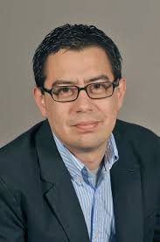
Cesar Jaramillo is executive director at Project Ploughshares, a division of the Canadian Council of Churches. In 2017 Project Ploughshares’ coalition won the Nobel Peace Prize for their role in negotiating the UN’s Treaty on the Prohibition of Nuclear Weapons. Cesar’s areas of expertise include nuclear disarmament, outer space security, and conventional weapons control. As an international civil society representative, he has addressed the UN General Assembly First Committee (Disarmament and International Security) and the UN Conference on Disarmament, among others.

Panel 3: Learning from allies

Clara Portela is currently an analyst with the EU Institute for Security Studies in Paris (France). She has previously worked as a faculty member at the University of Valencia (Spain) and Singapore Management University (Singapore). She holds a PhD from the European University Institute (EUI) in Florence (Italy) and an MA from the Free University of Berlin (Germany). Her research focuses on European foreign policy with a focus on international sanctions. She has participated in consultative processes convened by the UN Secretariat, European Parliament, European External Action Service, the UN Economic and Social Commission for Western Asia and the Asia-Europe Foundation. She has been a Visiting Professor with OSCE Academy, the College of Europe and the University of Innsbruck (Austria), and a Visiting Scholar with Carleton University (Canada).

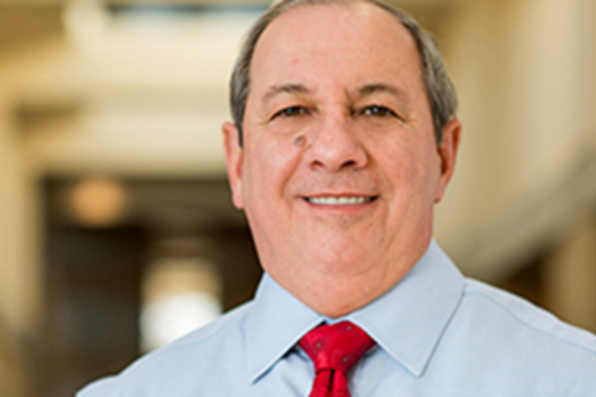
George Lopez is the Rev. Theodore M. Hesburgh, C.S.C., Professor Emeritus of Peace Studies at the Kroc Institute for International Peace Studies at the University of Notre Dame. In his thirty years of affiliation with the Kroc Institute he has served as the Vice-President of the Academy for International Conflict Management and Peacebuilding at the US Institute of Peace and also on the United Nations Panel of Experts for monitoring and implementing UN sanctions on North Korea. He has advised the United Nations, various international agencies, and governments regarding sanctions issues.

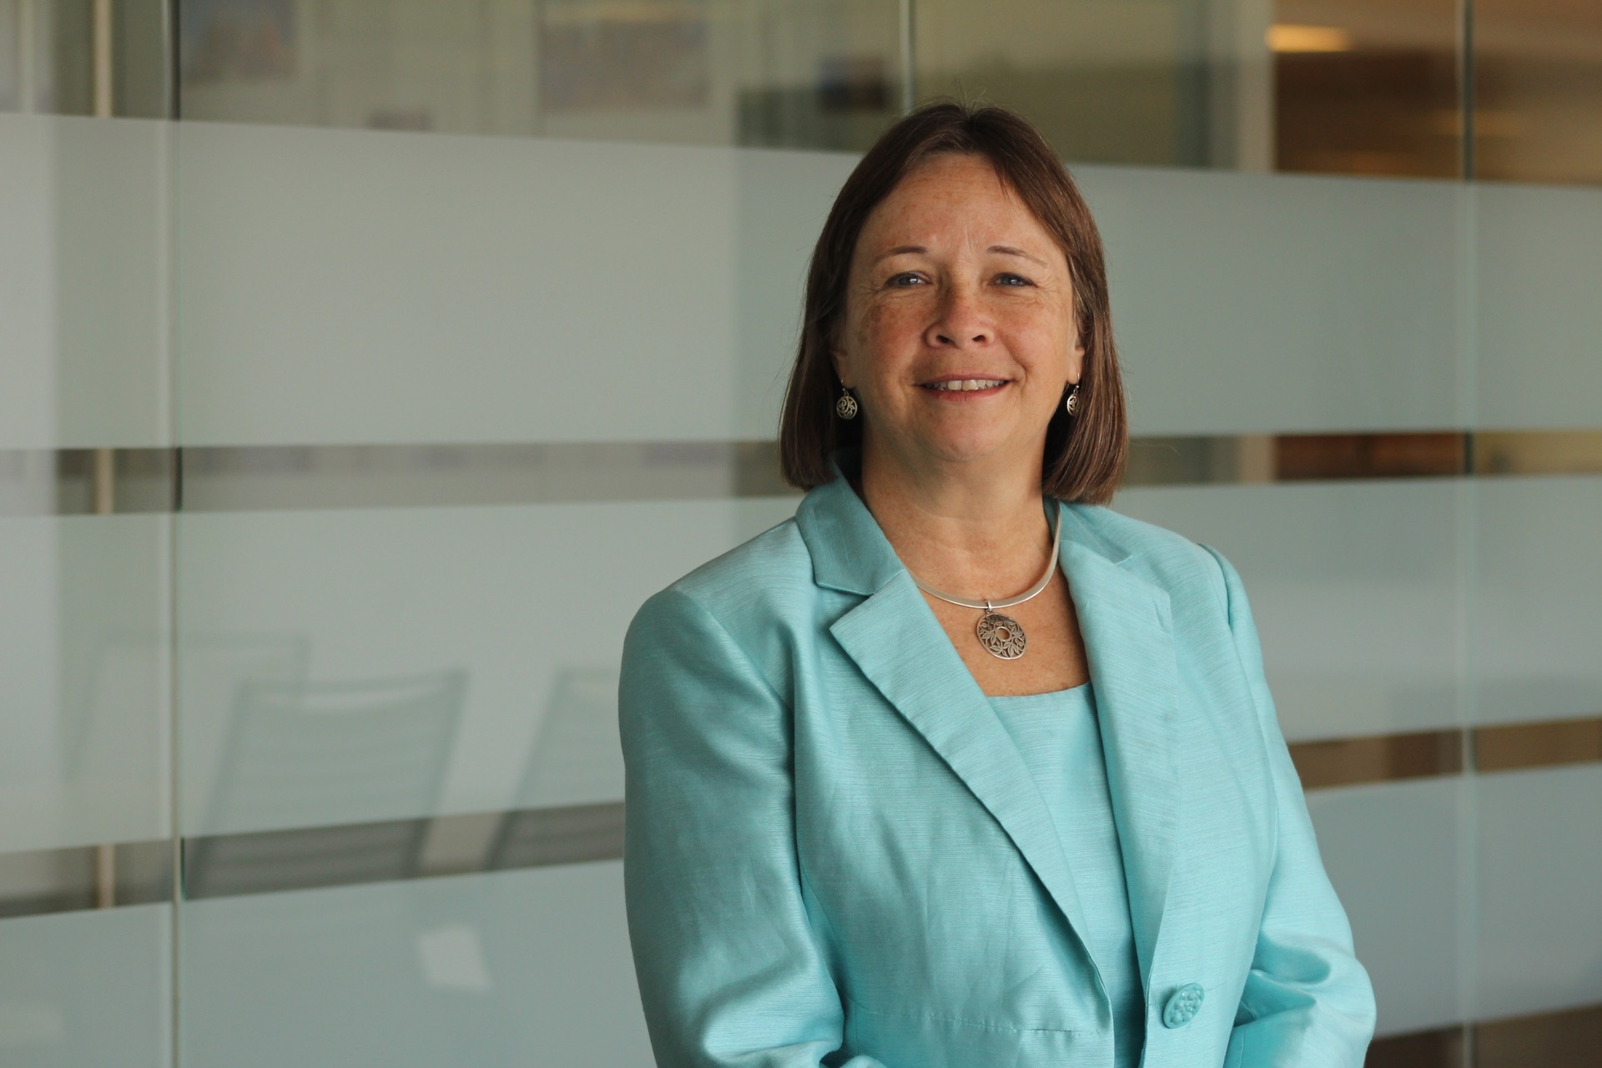
The Honourable Sue Eckert is Adjunct Senior Fellow at the Center for a new American Security. She was appointed by US President Clinton as Assistant Secretary of Commerce for Export Administration and was previously a member of the professional staff of the US House of Representative’s Committee on Foreign Affairs. She also co-led an international research initiative that examined the impacts and effectiveness of United Nations targeted sanctions, resulting in the creation of two new databases and a new online SanctionsApp and has testified before the US Congress and Canadian Parliament as well as the UN and European Committees.

Panel 4: Future of Sanctions

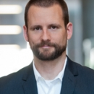
Thomas Juneau is Associate Professor at the Graduate School of Public and International Affairs at the University of Ottawa. Prior to this position he worked for the Department of National Defence primarily as a strategic analyst covering the Middle East. Dr. Juneau was also a policy officer and an assistant to the deputy minister. He has authored a number of books and articles and his research focuses on Canadian foreign and defence policy, international relations theory, and the Middle East, in particular, Iran and Yemen

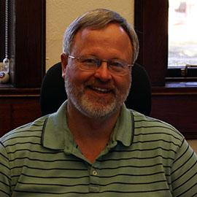
Clifton Morgan is the Albert Thomas Professor of Political Science at Rice University. His areas of interest include the application of formal models to the study of bargaining international crises and quantitative analyses of the causes of war. He has authored numerous books and scholarly articles. His current research on the use and effectiveness of economic sanctions has been supported by the National Science Foundation.

Alice Debarre is a Senior Policy Analyst in the Humanitarian Affairs program of the International Peace Institute. Prior to this position she was an associate in the Policy and Diplomacy division of the International Committee of the Red Cross in Geneva. She has also worked on human rights and national security issues at Human Rights First and for the International Humanitarian Law Unit of the American Red Cross. Dr. Debarre’s current work focuses on the delivery of healthcare in situations of armed conflict, forced displacement, and the impact of urbanization on humanitarian action.

